

| Group Members | Agu Gerald Ndubuisi / 20060356  Tochukwu Anene Ursula / 21062187  Marian Ejechi / 21062219  Annie Supriya Nattala / 21056368 |
| --- | --- |
| Module Title | Network Security |
| Module Number | LD7007 |
| Assignment | SSL PKI Implementation and Threat modeling on Windows Server 2016 - Group Assignment |
| Submission Date | 12/01/2023 |
| Module Tutor | Khaled El-Hussein |
| Report Word Count | 4938 |

**Contents**

Executive Summary 2

1.0 Introduction 2

2.0 Problem Statement 2

3.0 SSL PKI Design & Implementation 3

3.3 Certificate Services Configuration 18

3.4 Post CA Configuration Settings 23

3.5 Publishing The CRL 29

3.6 Server 2: Seldom Domain Controller 34

3.8 Group Policy Management For Certificate On DC 42

3.9 Server 3: Subordinate CA 45

3.10 Installation Of CA Certificate Generated From The Seldom Root On Subordinate 52

4.0 Create A Fully Operational TLS- Enabled Web Page 58

5.0 SSL Threat Modelling & Ethical Implications 63

5.1 PKI SSL Threat Ranking 66

5.2 PKI SSL Threat Mitigation 66

5.2.1 Mitigation Accomplished Primarily Through Mapping 67

5.2.2 The Use Of Client Certificates As A Mitigating Factor 68

5.3. PKI Risks 68

6.0 Conclusion 68

References 69

1

**EXECUTIVE SUMMARY**

Seldom is a security company that was founded in the early 1990s. Over the course of nearly two decades, it has gained a wealth of expertise in the security industry and has established a reputation for honesty, credibility, and collaboration with its clients. In order to provide its customers and employees with secure Internet connections, Seldom implemented a Public Key Infrastructure (PKI) with a two-tier architecture. In this system, the Certification Authority (CA) functions as a Subordinate CA, issuing web host certificates on behalf of the root CA. Unfortunately, Seldom has encountered some challenges with its PKI implementation. It has also suffered from two significant attacks that had a serious impact on privacy. These attacks highlight the importance of robust security measures, as well as the need to be prepared for potential vulnerabilities and threats.

**1.0** **INTRODUCTION**

Seldom is a security company that was founded in the early 1990s and has gained extensive expertise in the security industry. It is known for its honesty, credibility, and collaboration with clients, and has implemented a Public Key Infrastructure (PKI) with a two-tier architecture in order to provide secure Internet connections.

PKI is a system of encryption and cybersecurity that uses digital certificates and certificate authorities (CAs) to verify the identity of devices or individuals and establish trust between parties. In a two-tier PKI architecture, there is a root CA at the top tier and one or more subordinate CAs at the second tier. The subordinate CAs can issue certificates on behalf of the root CA, allowing for a more decentralized and scalable PKI system.

PKI can be used to provide Confidentiality, Integrity, Authentication, and Authorization in situations where digital security is necessary, such as for electronic transactions, SSL signatures, encrypted documents, and contactless payment logins. By hosting these components on a secure framework, PKI helps protect the identities and private information involved in these processes. Seldom has encountered some challenges with its PKI implementation and suffered from two significant attacks that have a serious impact on privacy. However, its commitment to advanced security technologies like PKI and its reputation for honesty and credibility has helped it achieve success in the security industry.

**2.0** **PROBLEM STATEMENT**

As we worked with the X.509-based standard, we discovered several issues and shortfalls. The usage of technology was the primary cause of most issues. As the project progressed, additional administrative roadblocks appeared that needed to be overcome. In a nutshell, it has been determined that PKI's architecture has three essentially problematic elements.

* Technology, particularly the challenges that come from the fundamental concepts that constitute the basis of the whole Public Key Infrastructure.
* Administration, which refers to problems arising from the use of the technology
* Preoccupations with respect to general safety and security It appears that basic safety considerations are disregarded while employing this technology.

2

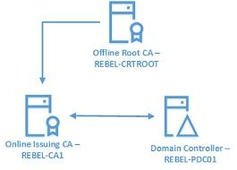

Figure 1: Two-Tier PKI Architecture.

**3.0** **SSL PKI DESIGN & IMPLEMENTATION**

Before implementing the PKI in Seldom organizations, a demonstration was conducted in a licensed VMware workstation pro with the official Windows server 2016 version in a virtual testing environment. VMware Workstation is software used to host various operating systems via virtual machines. Each virtual machine can run a distinct version of Windows, Linux, macOS, etc. VMware Workstation provides extensive hardware compatibility support and works as a middleman for all sorts of hardware resources between the host and the virtual machine.

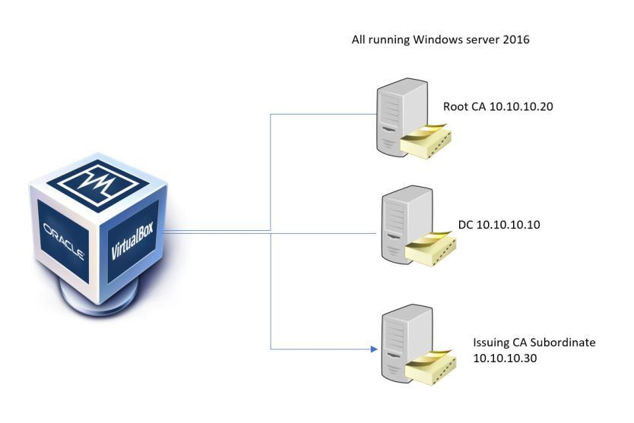

Figure 2: Lab setup and Network details

3

**3.1** **INITIAL SETUP OF ALL THE CERTIFICATE SERVERS**

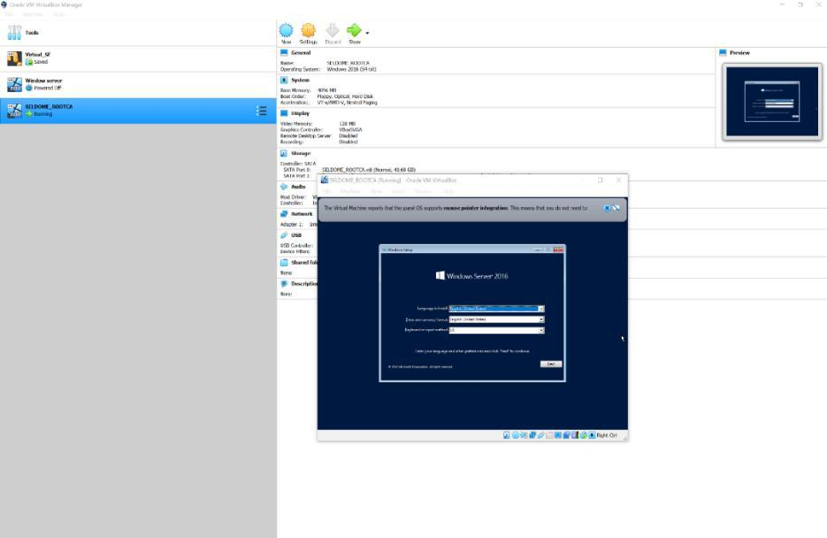

Figure 3: Windows Server 2016 Installations (A)

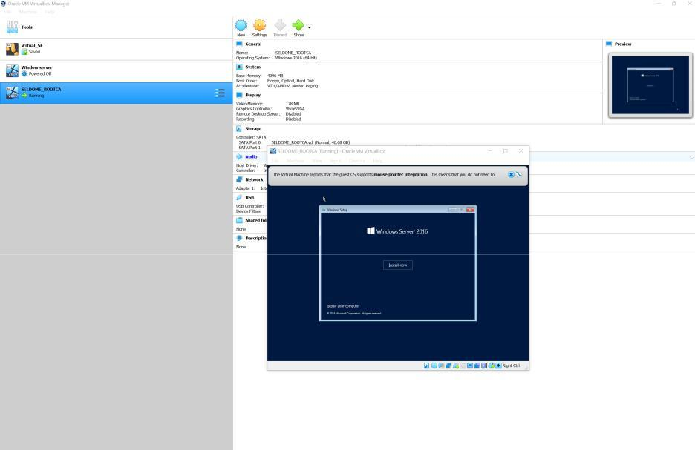

Figure 4: Windows Server 2016 Installation(B)

4

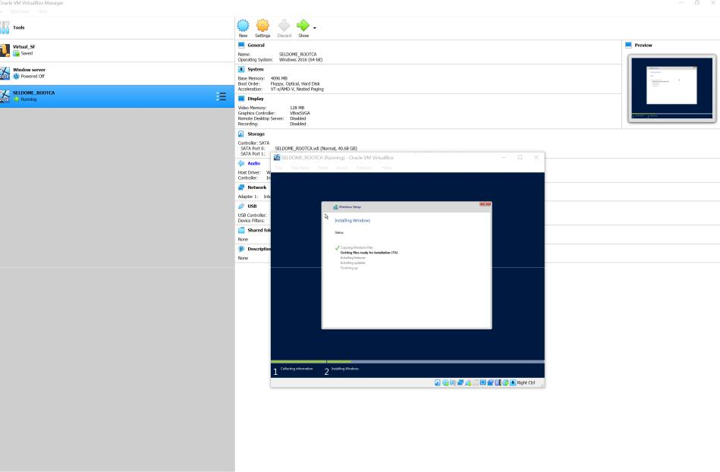

Figure 5: Windows Server 2016 Installation(C)

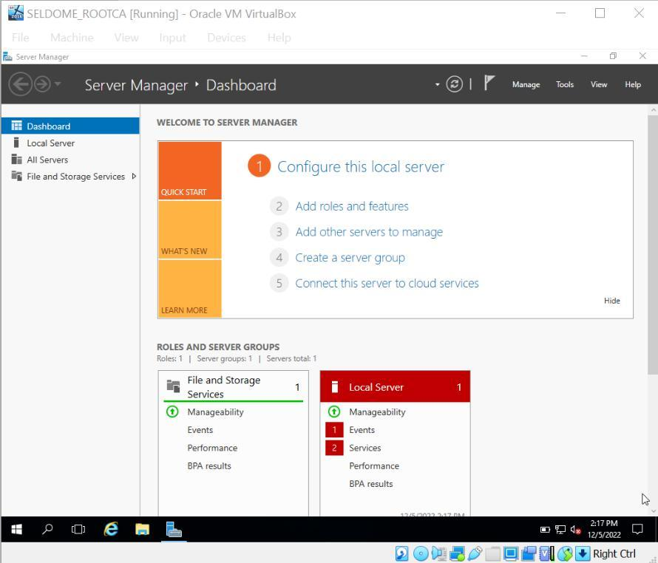

Figure 6: Server Installed and Running

5

**3.2** **SERVER 1: CREATING A STANDALONE ROOT CA**

The procedure begins with the creation of a standalone root CA. This server does not belong to a domain and is instead configured for workgroup mode. When the server is configured, log in as a member of the local administrator group and make the following modifications.

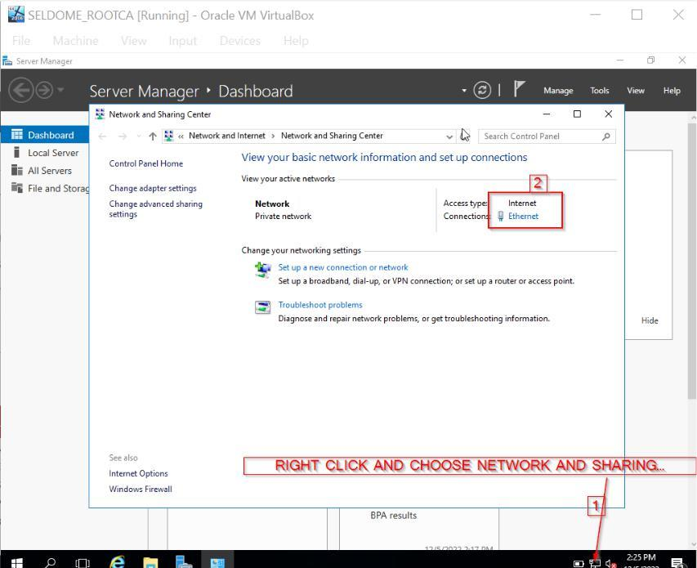

Figure 7: Assigning an IP address to the SELDOME_ROOTCA (A)

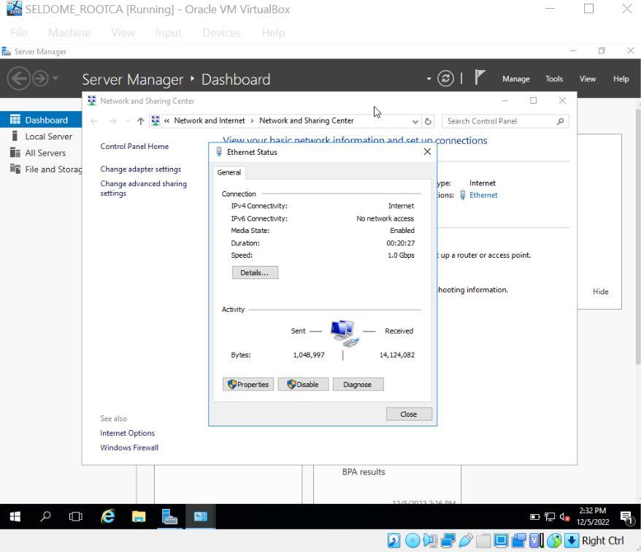

Figure 8: Assigning an IP address to the SELDOME_ROOTCA (B)

6

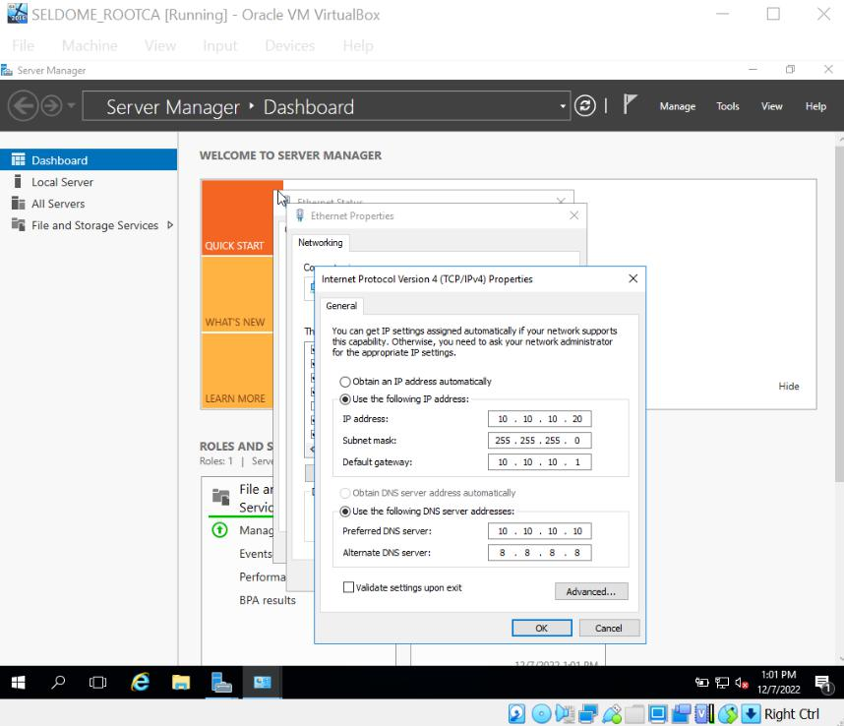

Figure 9: Assigning an IP address to the SELDOME_ROOTCA (C)

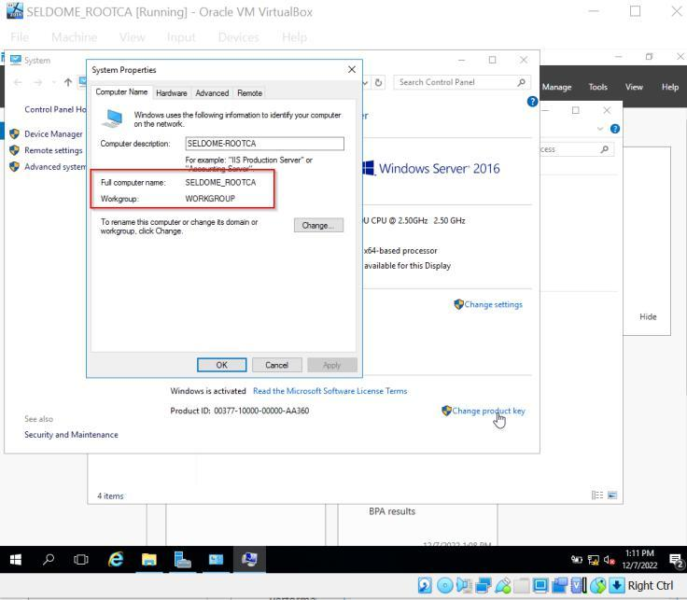

Figure 10: Setting up the Network Server (A)

7

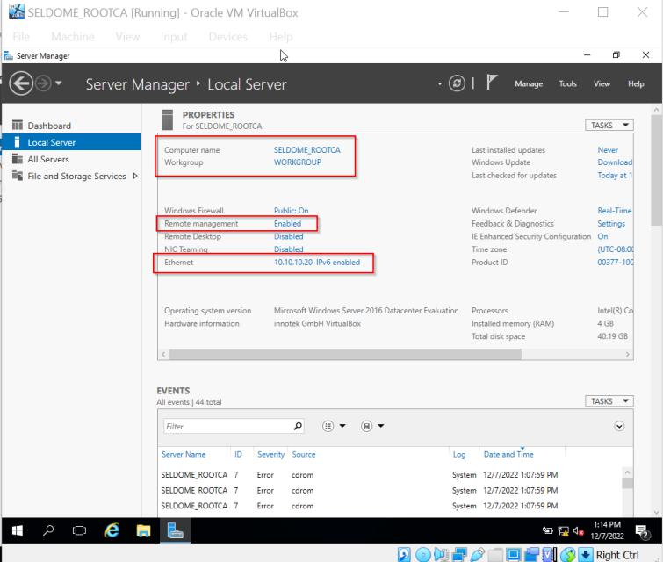

Figure 11: Setting up the Network Server (B)

Active Directory Certificate Service must initially be configured. Navigate into the server management to Manage > Add Roles and Features.

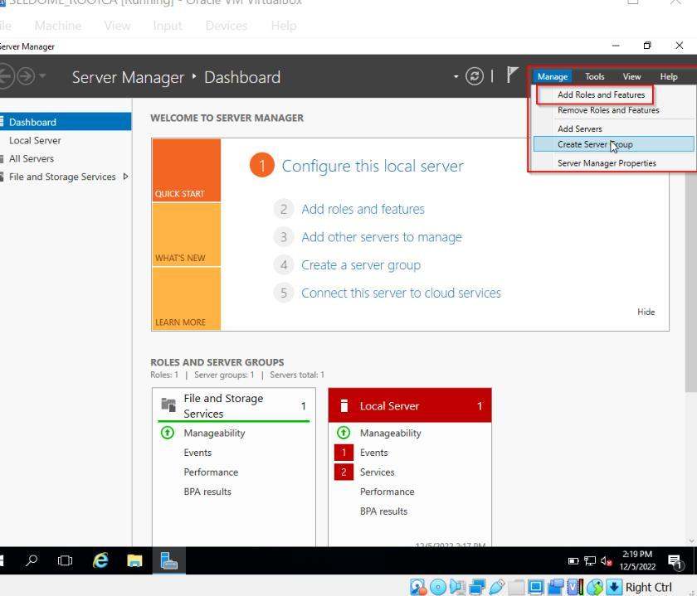

Figure 12: Adding Roles

8

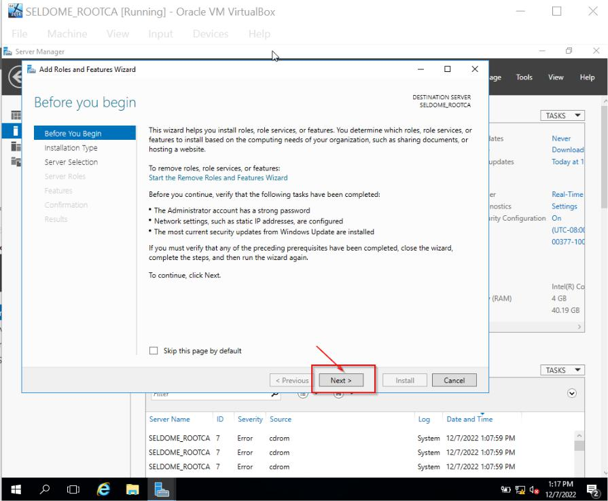

Figure 13: Adding Roles (Following the Wizard)

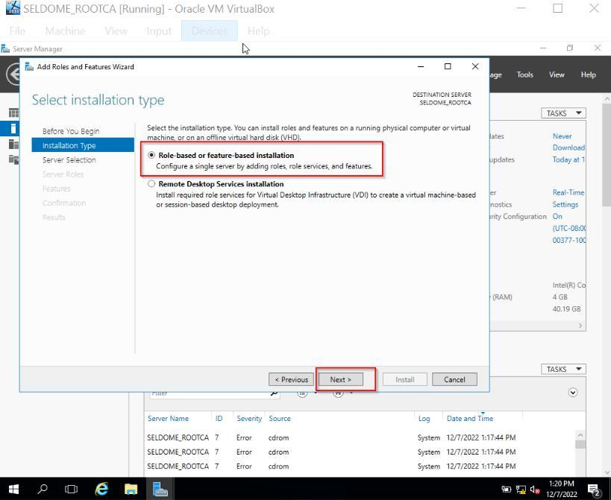

Figure 14: Adding Roles (Installation Types)

9

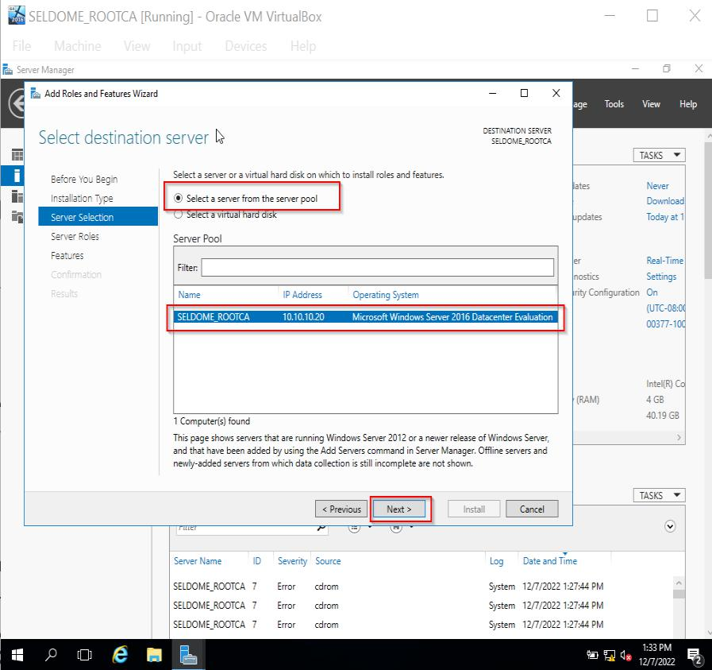

Figure 15: Selecting a Server from the Server Pool

Proceed by selecting Active directory certificate services under Server Roles.

10

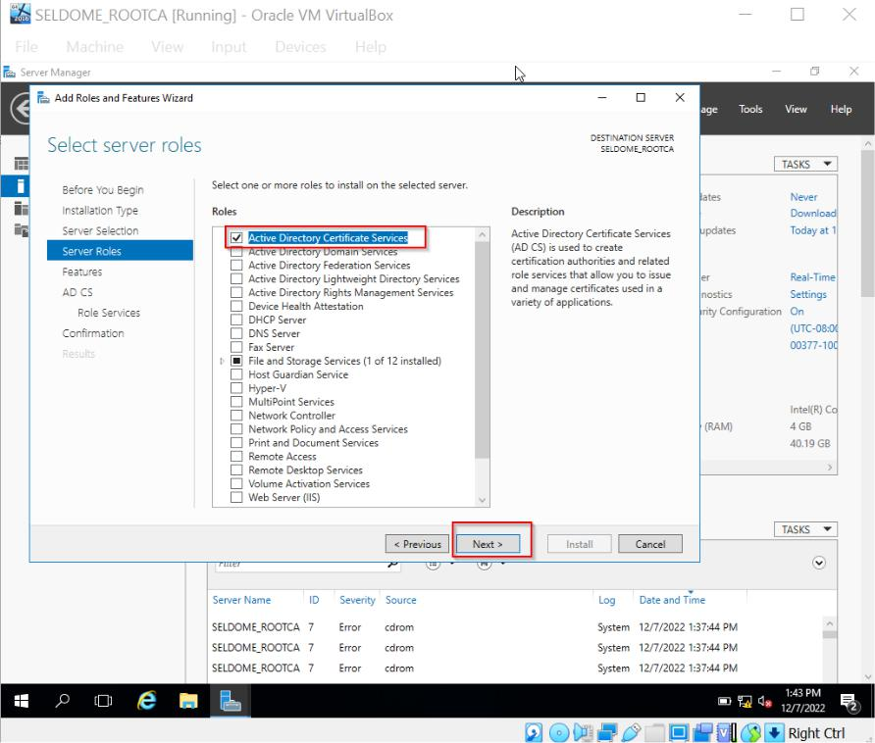

Figure 16: Selecting AD Certificate Services

Proceed and choose Certification Authority under AD CS > Role services.

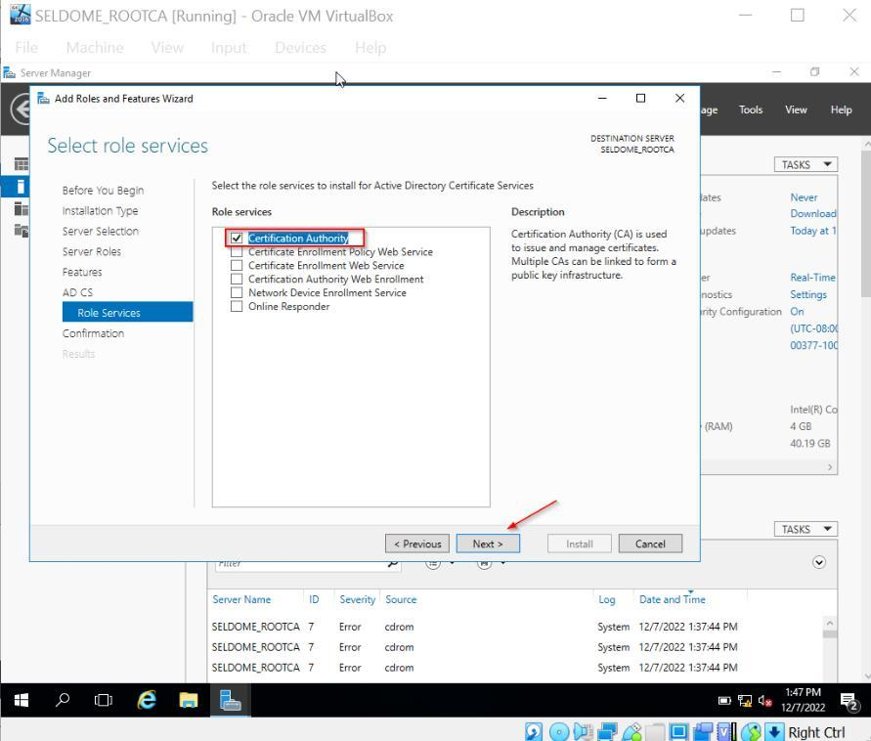

Figure 17: Selecting CA in ADCS

11

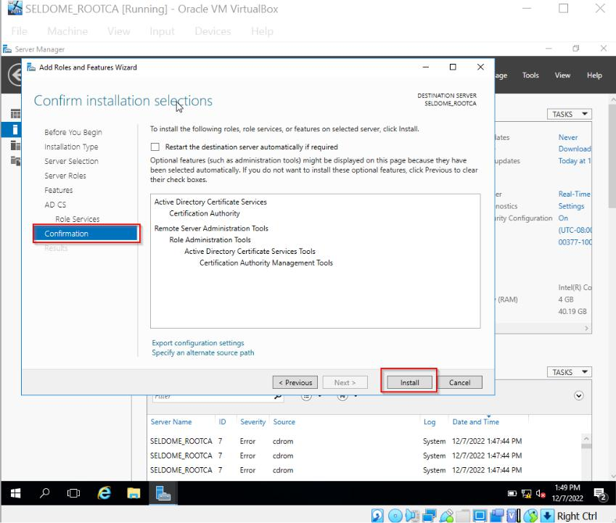

Figure 18: Highlights of selected services

Installation is now complete.

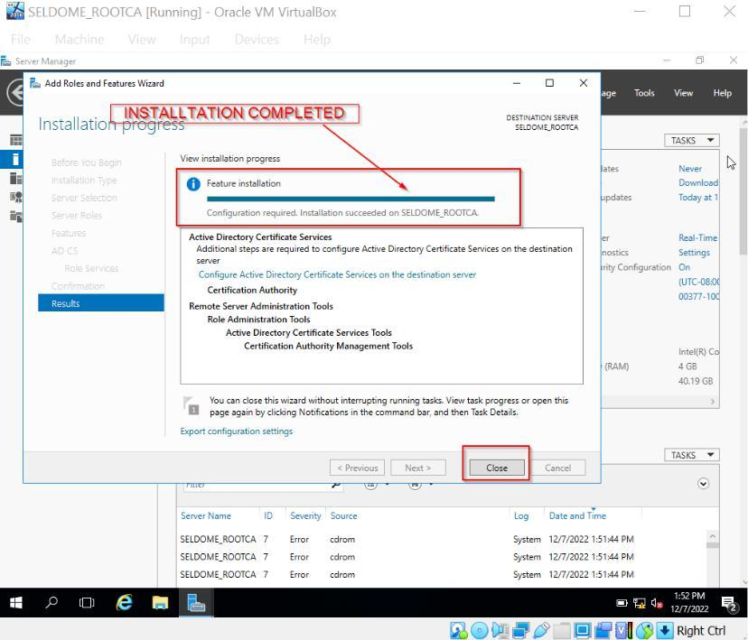

Figure 19: Installation Complete

12

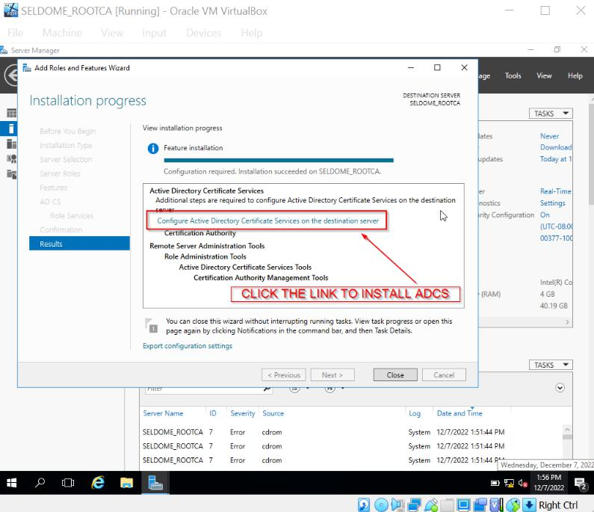

Figure 20: Link to Install ADCS

13

**3.3** **CERTIFICATE SERVICES CONFIGURATION**

After the ADCS installation is complete, the server's ADCS needs to be configured. We will configure role services to install CA in the configuration windows with the aid of autogenerated credentials.

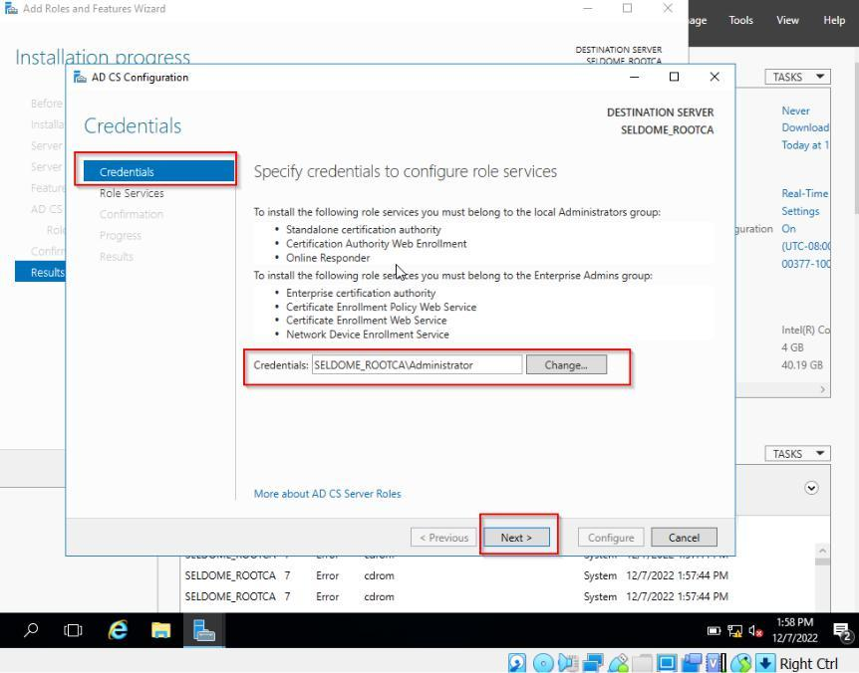

Figure 21: specifying credentials for role services

**Step 1:** The next step is to select the certifying authority and proceed

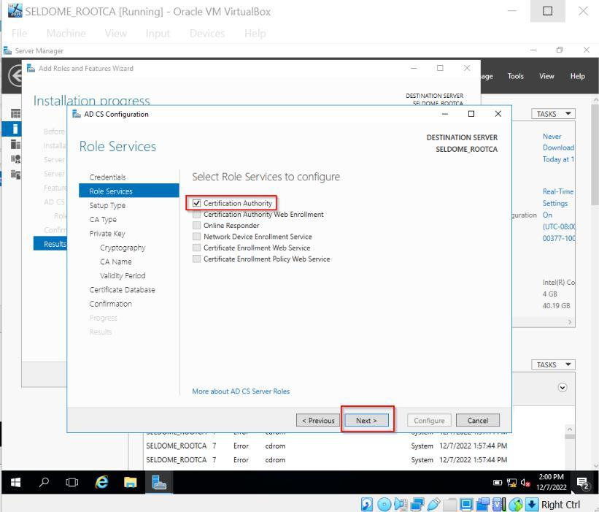

Figure 22: Selecting Certificate Authority

17

**Step 2:** Considering the server is not integrated with Active Directory, we must choose "Standalone CA.".

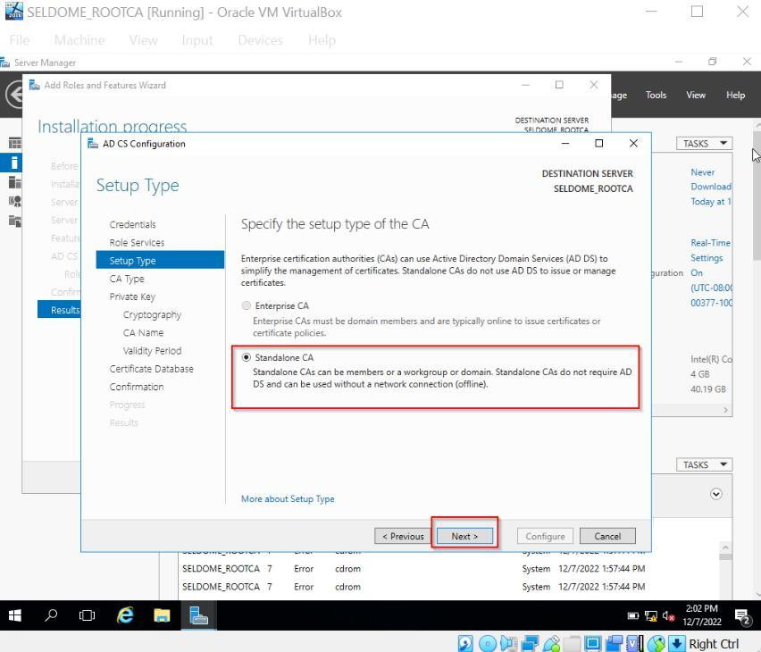

Figure 23: Selecting Standalone CA

**Step 3:** Set Root CA as the certificate authority, keeping in mind that this server would be the first in our chain of trust.

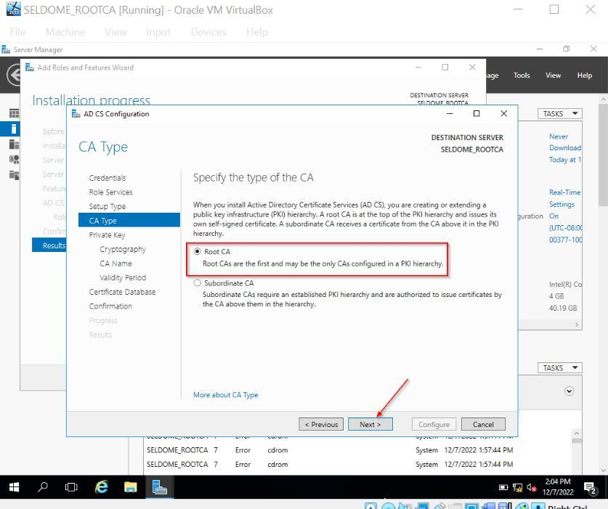

Figure 24: Selecting Root CA

19

**Step 4**: Since none of the keys we have are currently in use, we must create a new private key

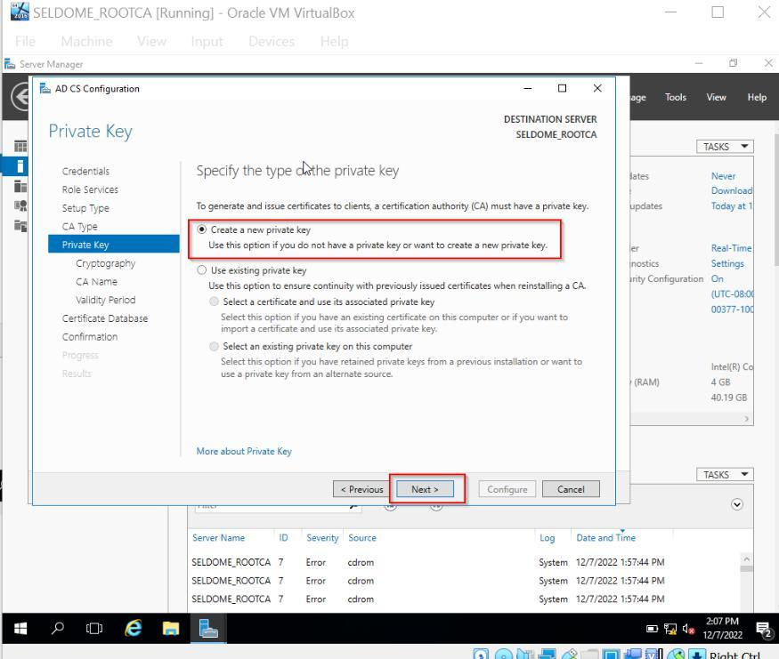

Figure 25: Selecting private key

Two of the most important parts of cryptography are choosing the right hash type and key length. Network eavesdropping might jeopardize the security of conveyed data. Therefore, if we use the safe hash, the communication will be secure. Decided on SHA -256.

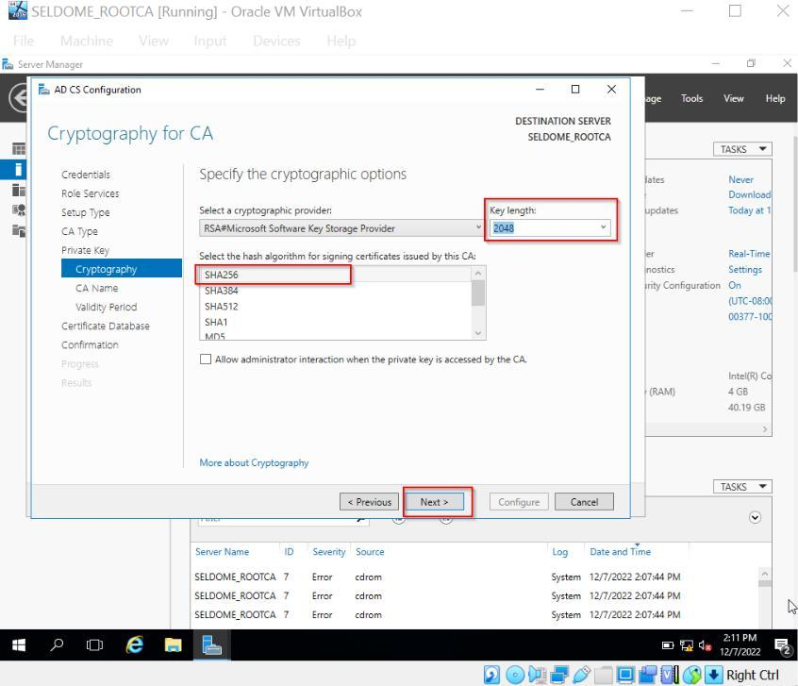

Figure 26: Cryptography for CA

20

**Step 6**: This is the place to rename the CA if we wish to. This has been decided and cannot be changed. We may also use default names.

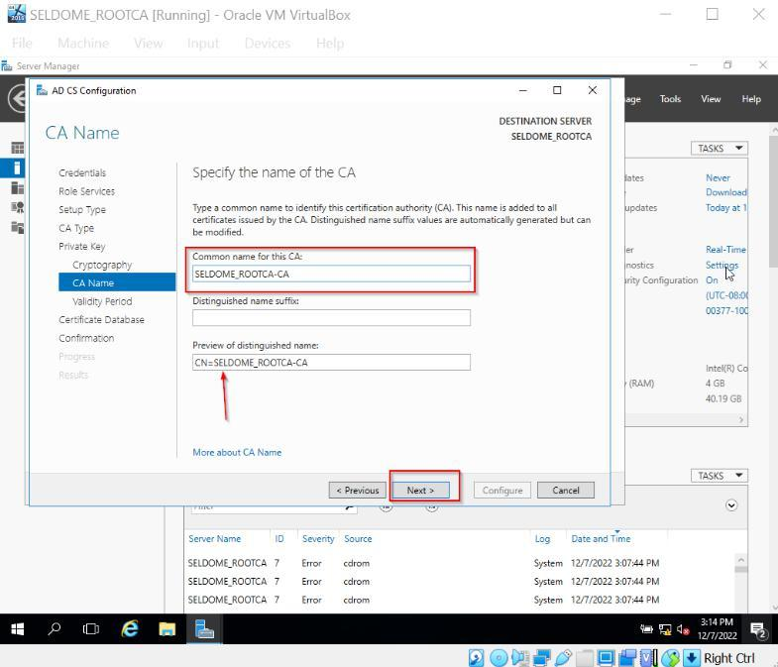

Figure 27 CA Name

**Step 7:** We believe a certificate's validity duration of 10 years is suitable.

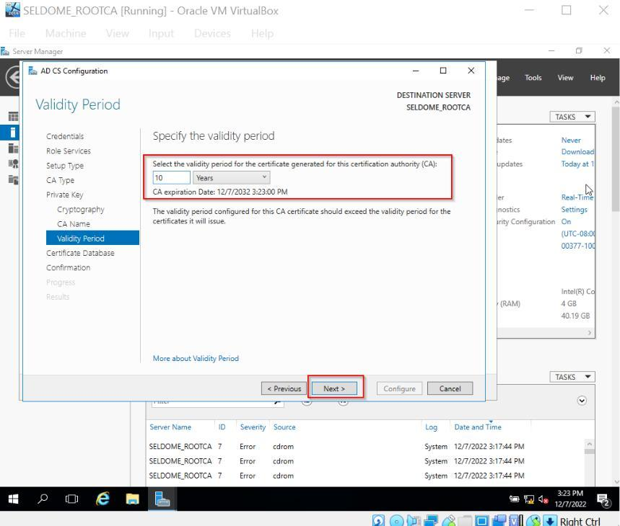

Figure 28 Validity Period

21

**Step 8:** Use the default database locations, unless otherwise specified.

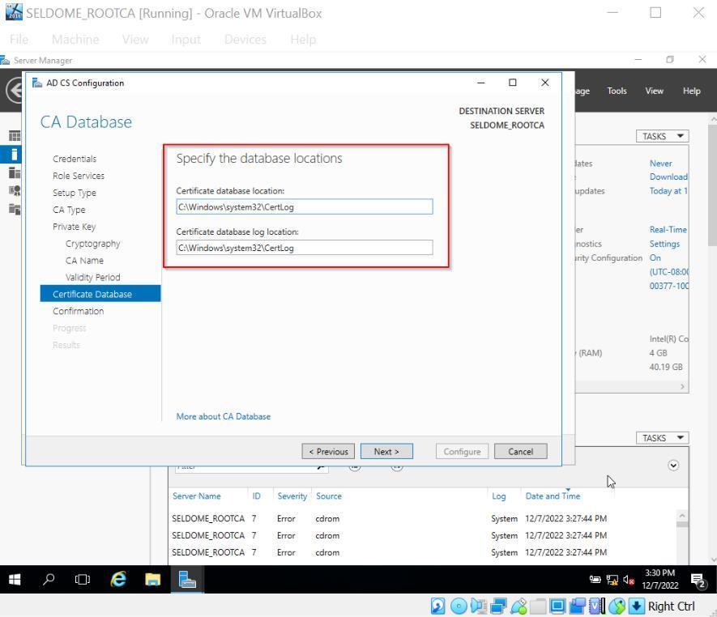

Figure 29: CA DB Location

**Step 9**: Check the final configuration and review it.

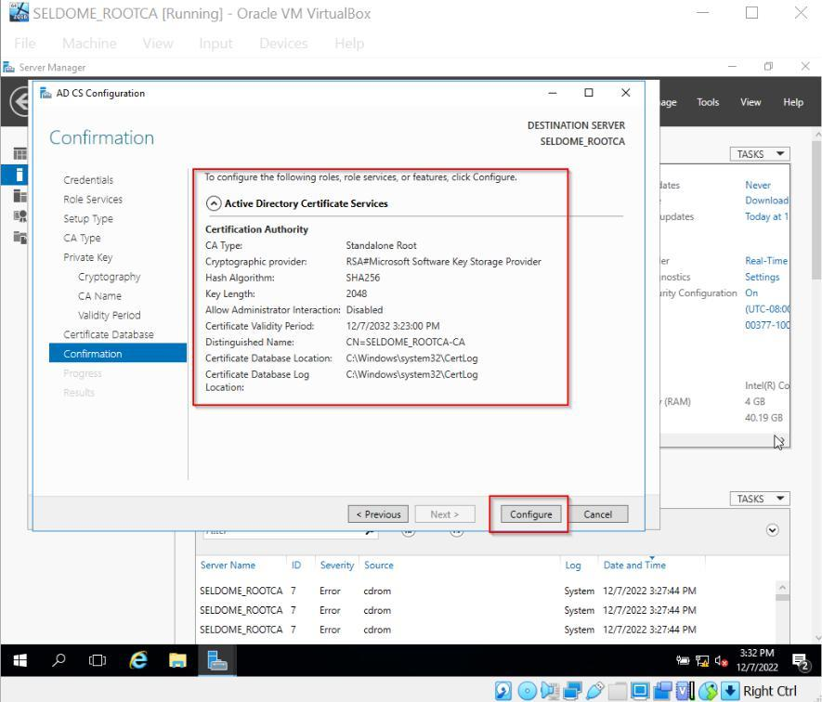

Figure 30: Confirmation

22

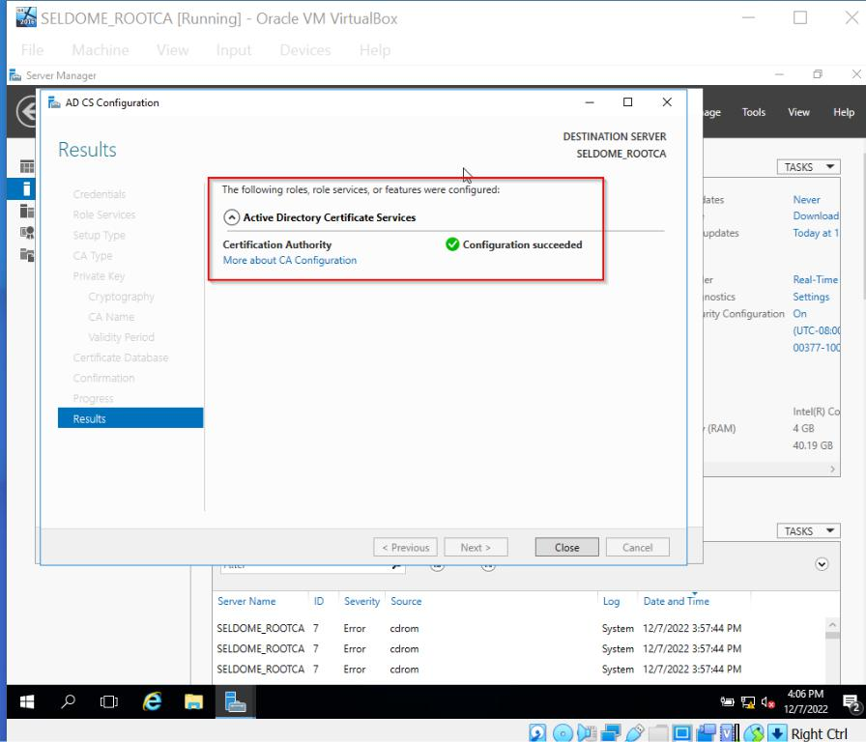

Figure 31: Configuration succeeded

**3.4** **POST CA CONFIGURATION SETTINGS**

The Certification Authority (certsrv.msc) is now accessible to us, or we should be able to do so via the Server Manager > Tools > Certification Authority menu.

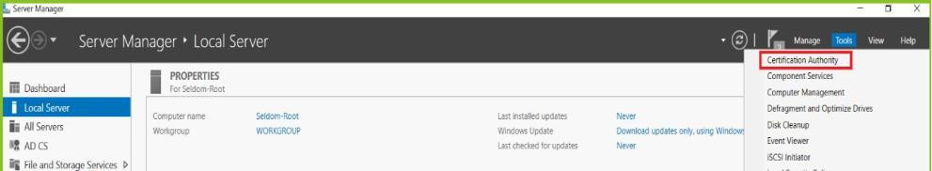

Figure 32 - Selecting CA for certificate properties

23

**Step 1**: Right-click *revoked certificates and* click on *Properties*.

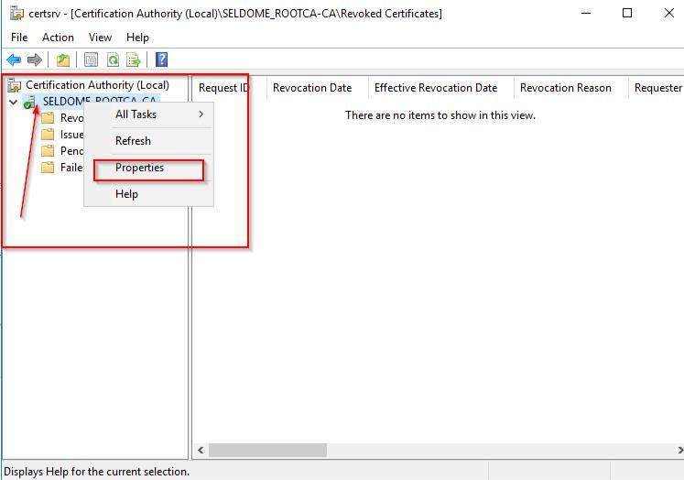

Figure 33: properties configuration (A)

**Step 2:** Select Extension from Properties

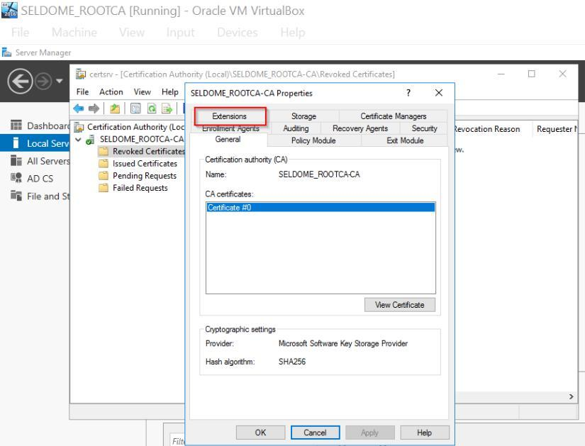

Figure 34: extension setup (A)

24

**Step 3:** Select the CRL Distribution Point as your extension and click on the Add button.

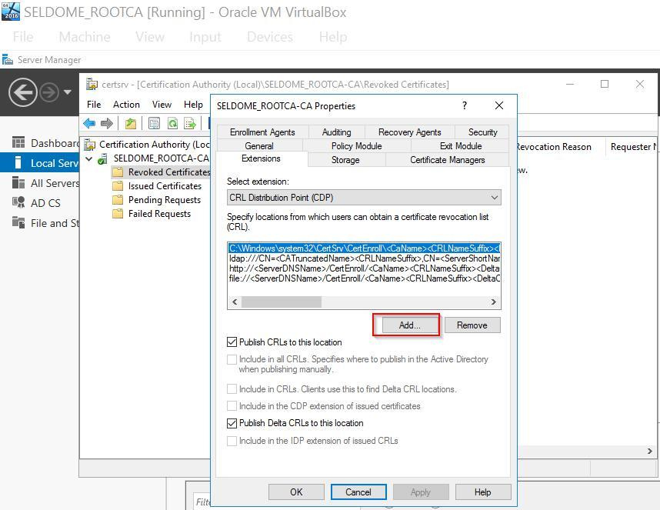

Figure 35: extension setup (B)

**Step 4:** Insert variables into the location. Location Link:

*http://pki.seldome.com/CertData/<CaName><CRLNameSuffix><DeltaCRLAllowed>.crl*

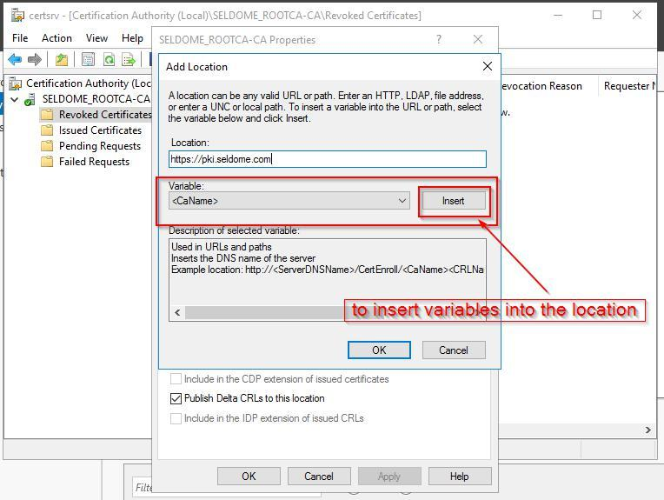

Figure 36: location setup (A)

25

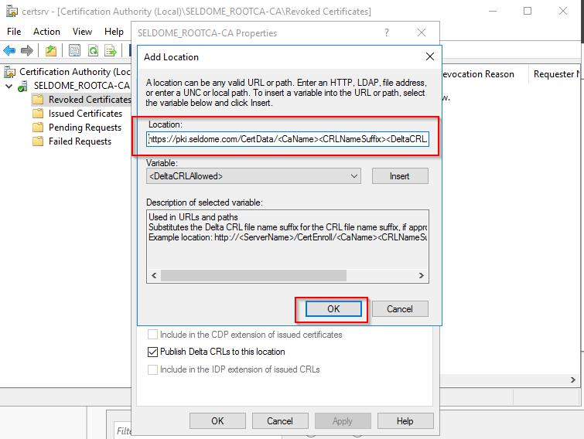

Figure 37: location setup (B)

**Step 5:** Tick the *Include in CRLS* and *Include in the CDP extension* boxes only.

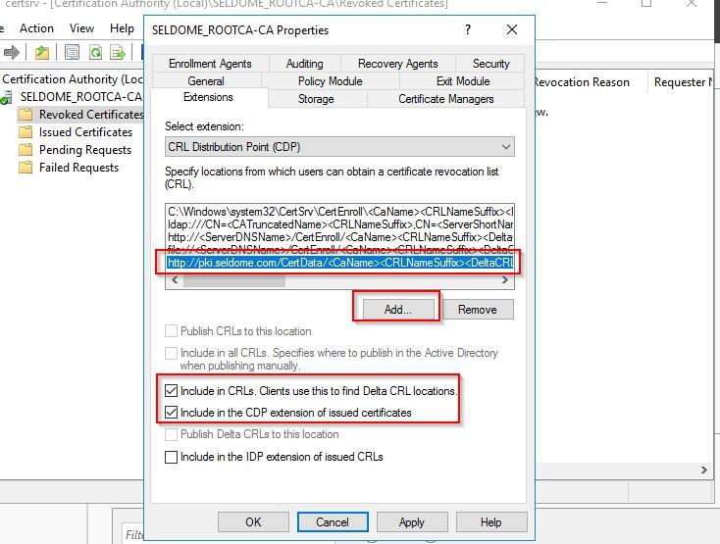

Figure 38: location setup (C)

**Step 6:** The next step is to use AIA in the same way. From the Extension menu, choose "AIA," then click "Add." Make sure the checkbox is only selected for our PKI. seldom local record and that it is deselected for all others.

http://pki.seldome.com/CertData/<ServerDNSName><CaName><CertificateName>.crt

26

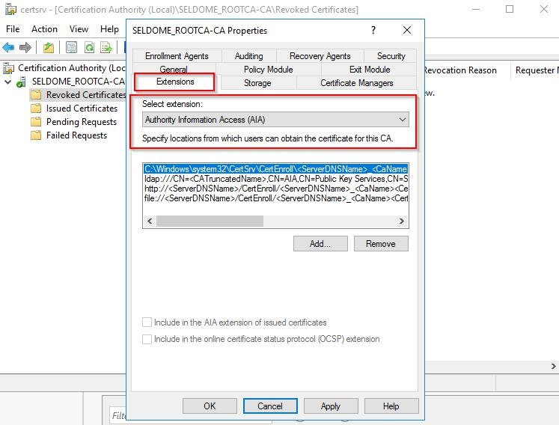

Figure 39: Root CA AIA (A)

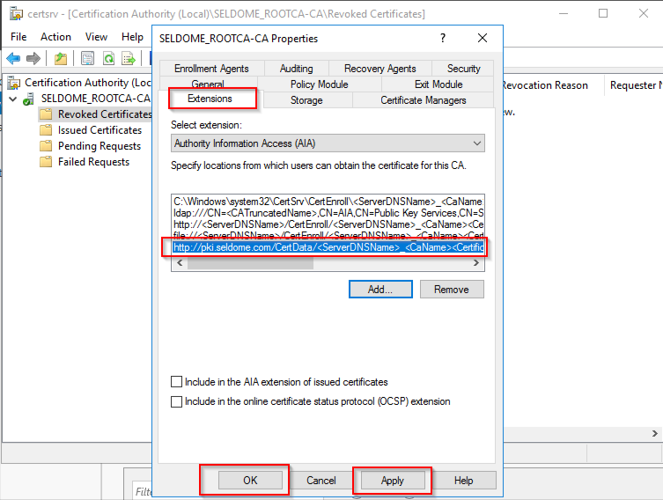

Figure 40: Root CA AIA (B)

27

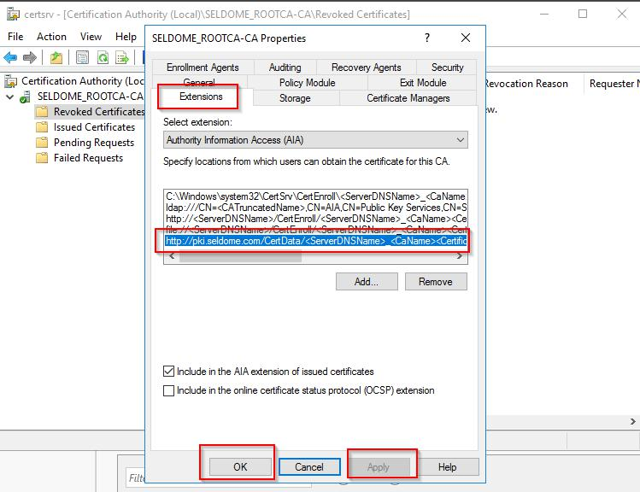

Figure 41: Root CA AIA (C)

**Step 7:** Right-click on the SELDOM Root CA and then choose the Auditing tab under the Certification Authority section of the Properties window. Bitmask values can also be used to configure Audit, as indicated in the table.

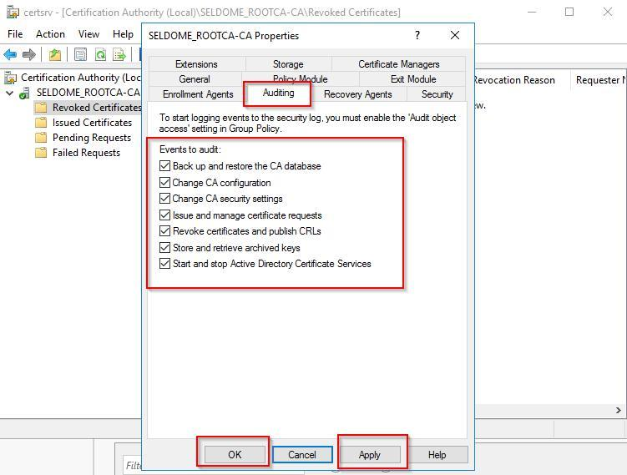

Figure 42 - Root CA AIA Auditing

28

**3.5** **PUBLISHING THE CRL**

We can now make our CRL public by right-clicking "Revoked

Certificates," choosing "All Tasks," and then "Publish." Select "New

CRL" when requested, then press the "OK" button.

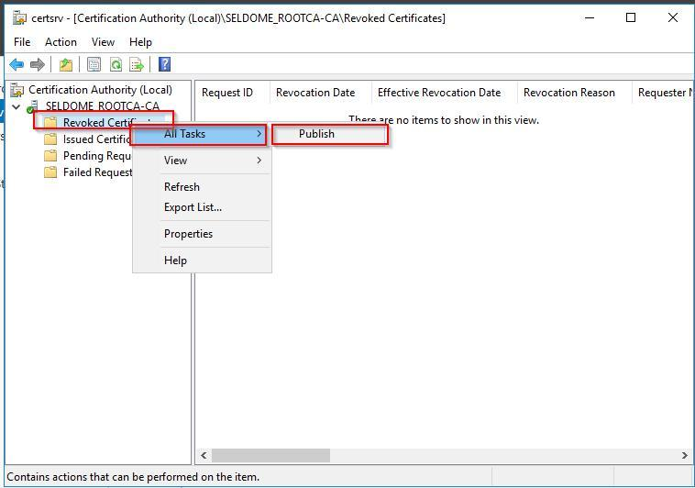

Figure 43 - CRL publishing (A)

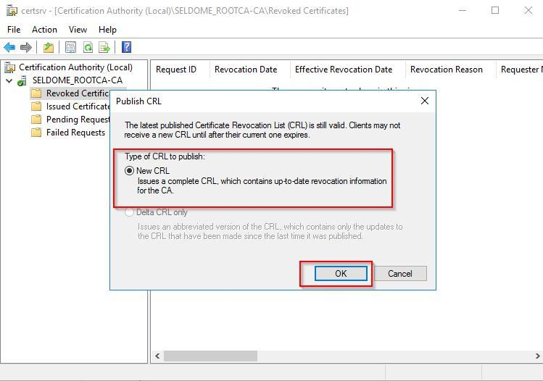

Figure 44 - CRL publishing (B)

Two files should now be present in the C:WindowsSystem32CertSrvCertEnroll folder, assuming everything went as expected. For later reference, kindly save these two files to your desktop.

29

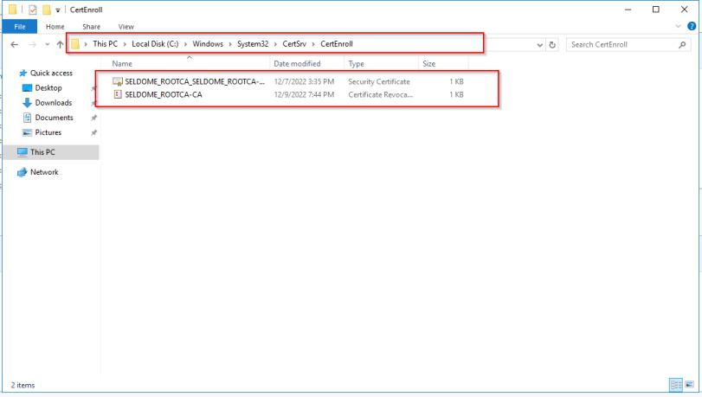

Figure 35 - Root Certificates

Therefore, after we get the information for the Crland AIA cert, we also need to add the server certificate. To accomplish this, we must copy the route to CertEnroll.

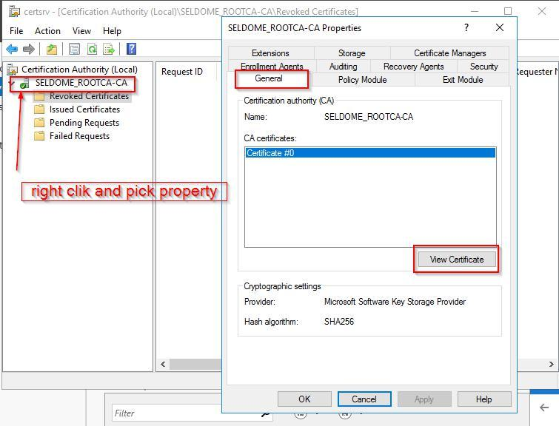

Figure 36 – Adding Server Certificate (A)

30

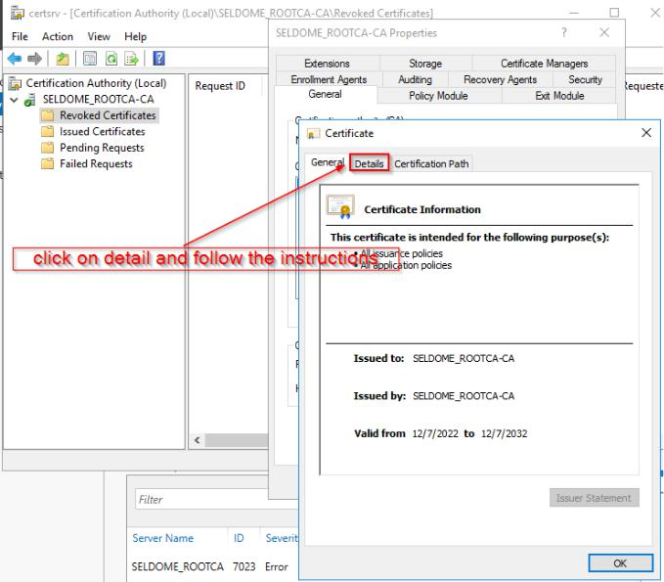

Figure 37 – Adding Server Certificate (B)

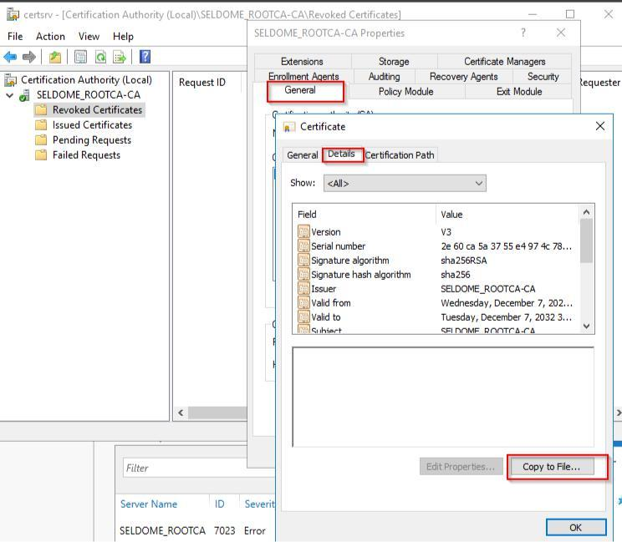

Figure 38 – Adding Server Certificate (C)

31

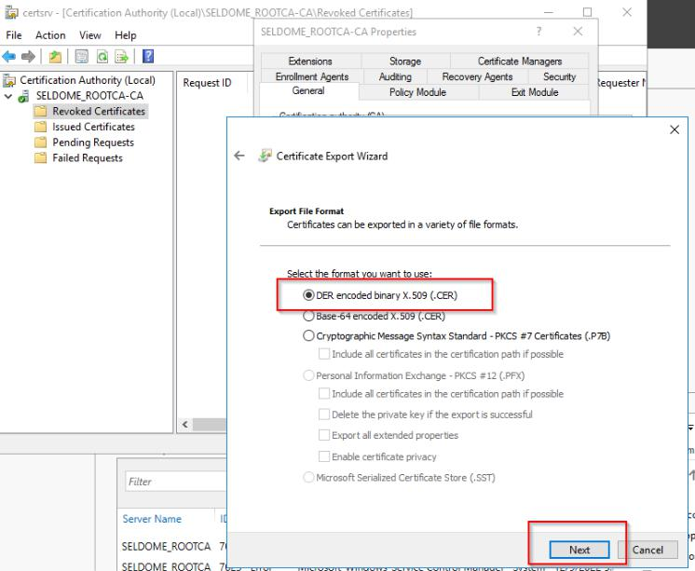

Figure 39 – Adding Server Certificate (D)

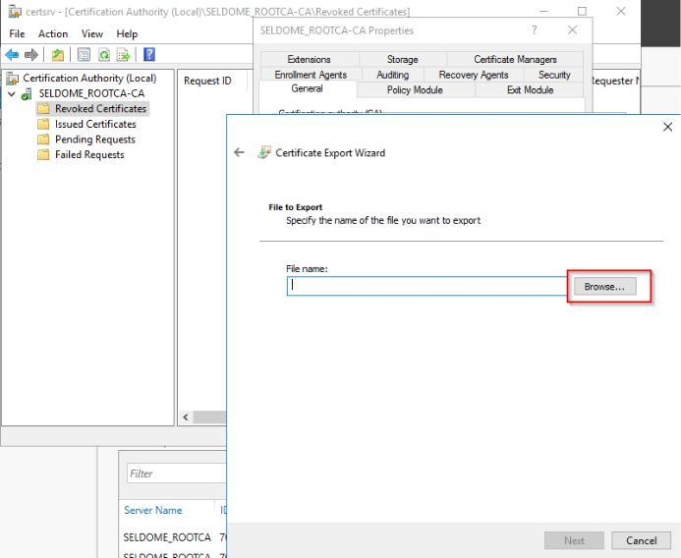

Figure 40 – Adding Server Certificate (E)

32

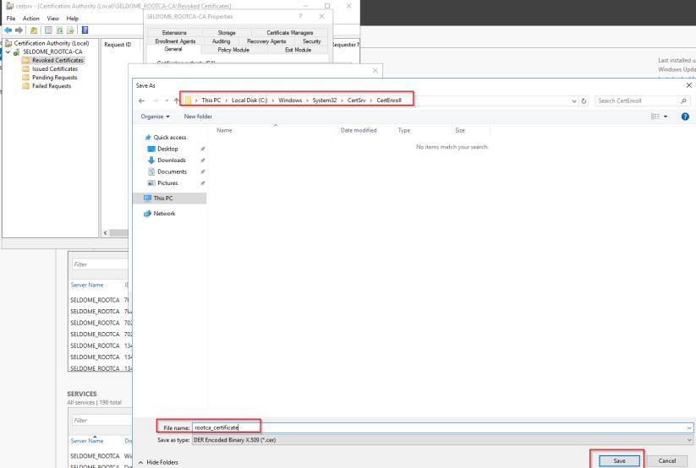

Figure 41 – Adding Server Certificate (F)

Now, Click on Save, Next and Finish

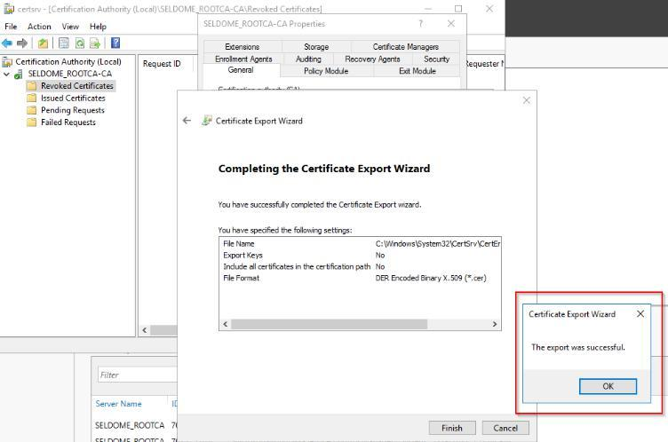

Figure 42 – Adding Server Certificate (G)

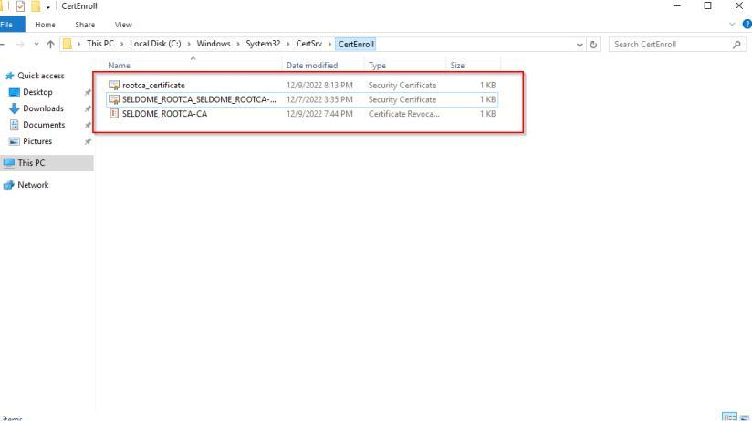

Figure 43 – Server Cert Added

33

**3.6** **SERVER - 2: SELDOM DOMAIN CONTROLLER**

In computer networks, a domain controller is a server that manages login requests and verifies user credentials. Using "domains," network users and machines may be arranged in a hierarchical framework. All of this data has to be organized and secured by the domain controller.

**Step 1**:The name, network, and security settings can be modified

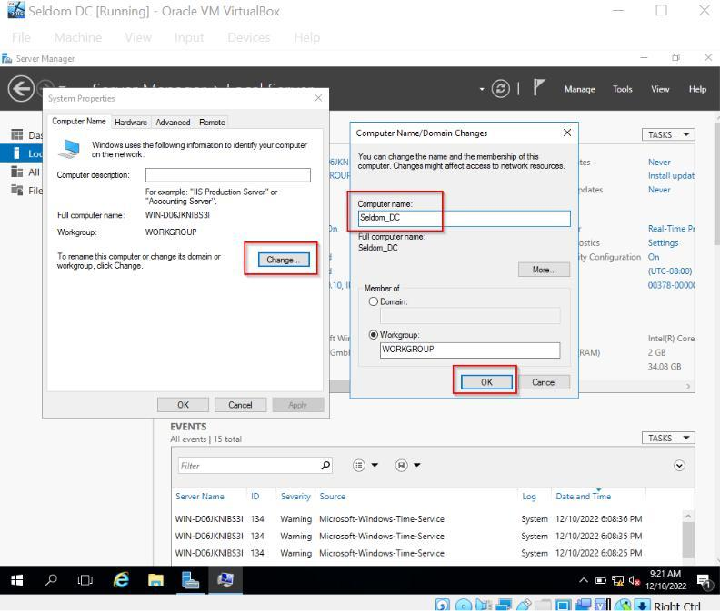

Figure 44– Domain Controller Configuration

**Step 2:** Role-based features and additional roles

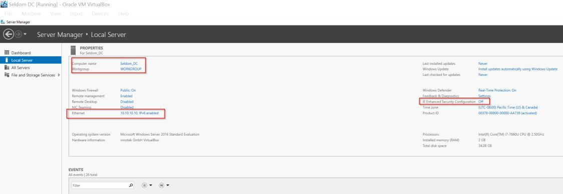

Figure 45– Selecting the Local Server

34

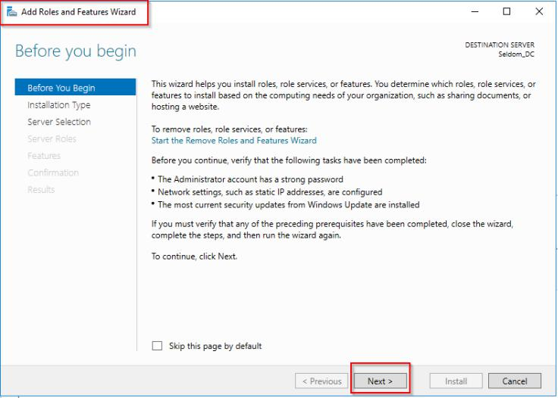

Figure 46– Using the Roles and Features Wizard

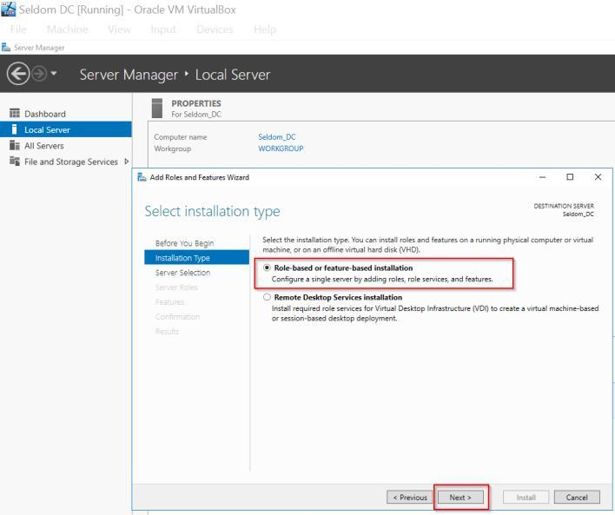

Figure 47– Selecting Installation Type

35

**Step 3:** Select the default server > selecting the server roles DNS server and Active Directory domain services

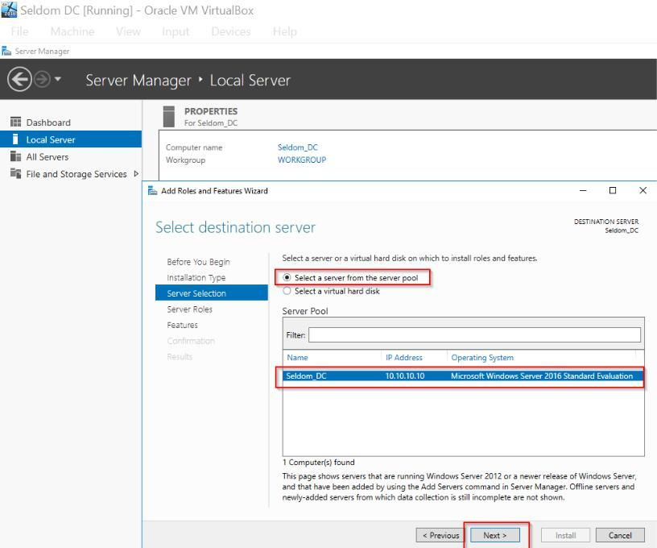

Figure 48– Selecting the previously configured server (seldom)

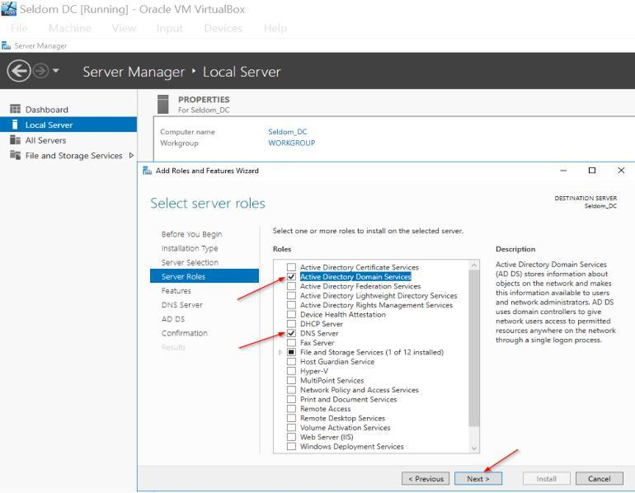

Figure 49– Selecting server Roles

36

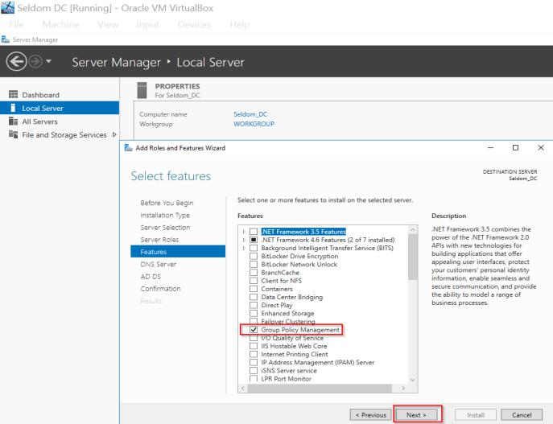

Figure 50– Selecting server Features

**Step 4:** Select the AD DS and DNS server defaults, then continue.

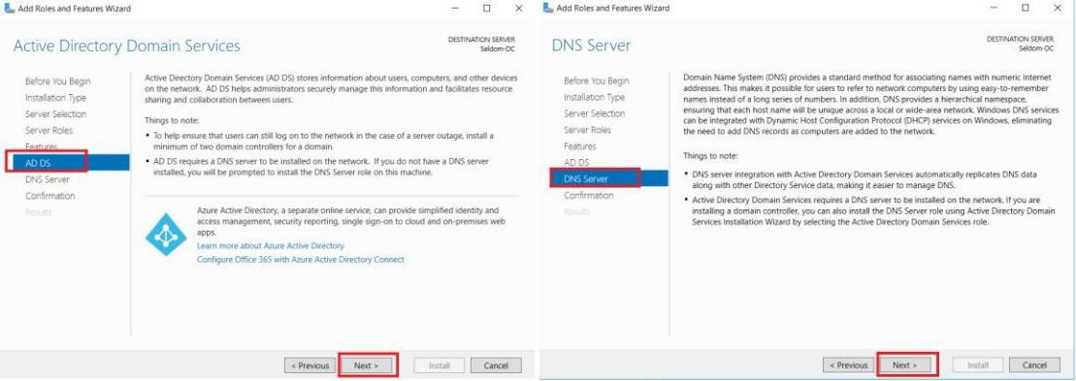

Figure 51– DC Roles

**Step 5:** Following the instructions, click Next. Then, click the "install" button. After the installation is complete, click Close.

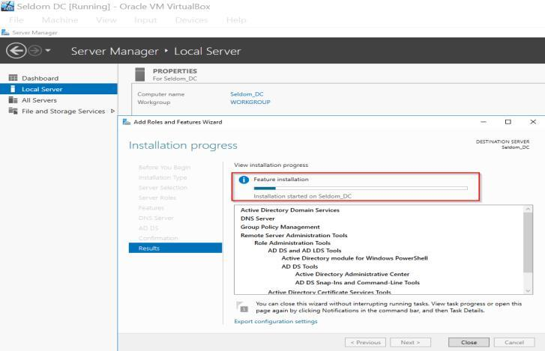

Figure 51– Completing Setup.

37

**3.7** **CONFIGURING THE DOMAIN CONTROLLER**

Step 1: Click on the “promote this server to a domain controller”

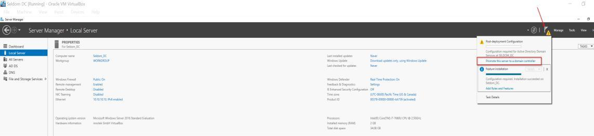

Figure 52: DC configurations

**Step 2:** Select a password and domain (pki.seldom.com) for the DC login.

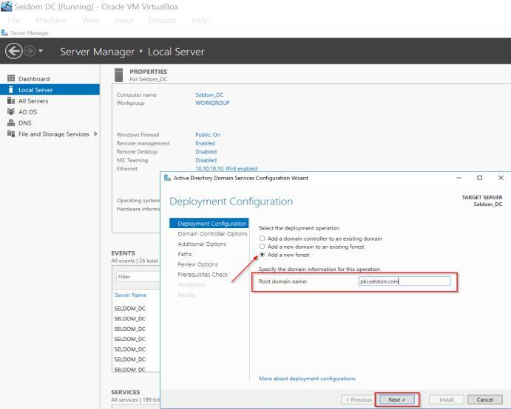

Figure 53– Deployment Config. (Root Domain Name)

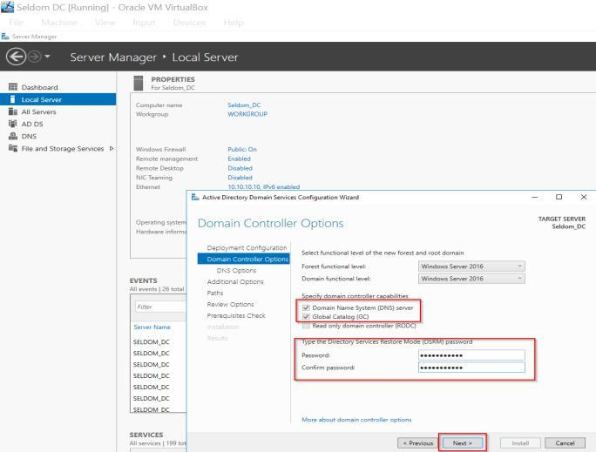

Figure 54– Deployment Config. (Password setup)

38

**Step 3:** Save the file using the default directories, then check the settings.

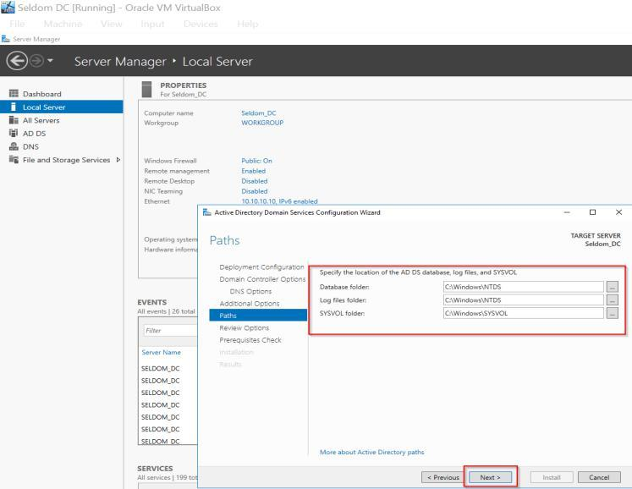

Figure 55 - Domain paths and review options

**Step 4:** Verify that the requirements check was successful.

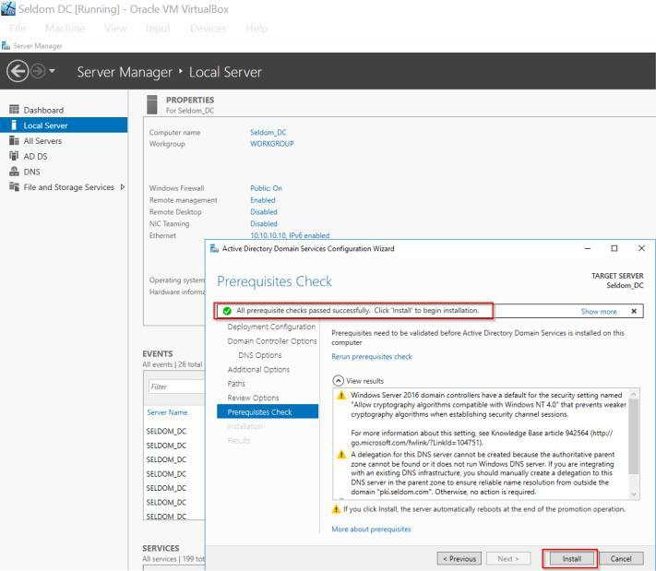

Figure 56 - Domain Prerequisites

39

**Step 5:** Get into the DNS settings

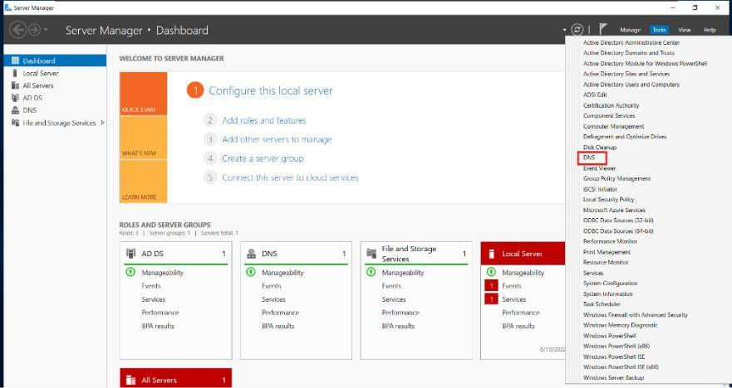

Figure 57 - Domain DNS

**Step 6:** To set up the domain, enter the DNS manager.

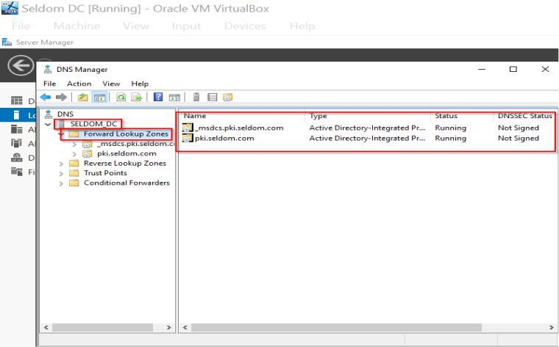

Figure 58 - Domain DNS manager (A)

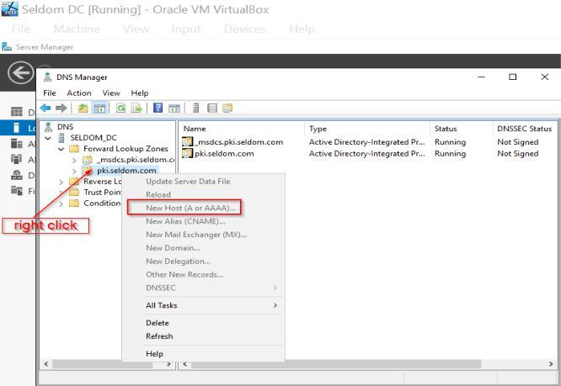

Figure 59 - Domain DNS manager (B)

40

**Step 7:** Specify the domain details and the web host's address.

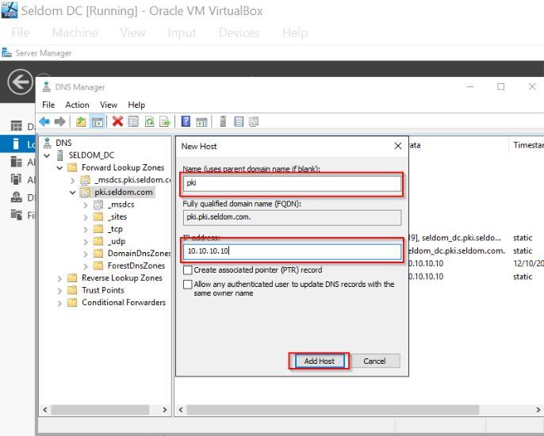

Figure 60 - Domain DNS New host (A)

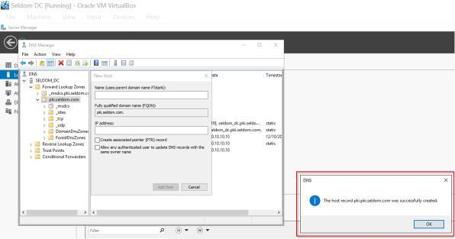

Figure 61 - Domain DNS New host (B)

41

**3.8** **GROUP POLICY MANAGEMENT FOR CERTIFICATE ON DC**

**Step 1**: Go to Tools and click on Group -> Policy Management.

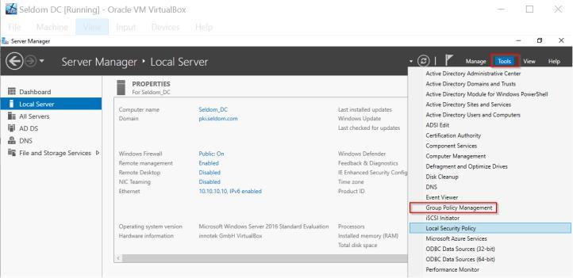

Figure 62 - Group-policy Management

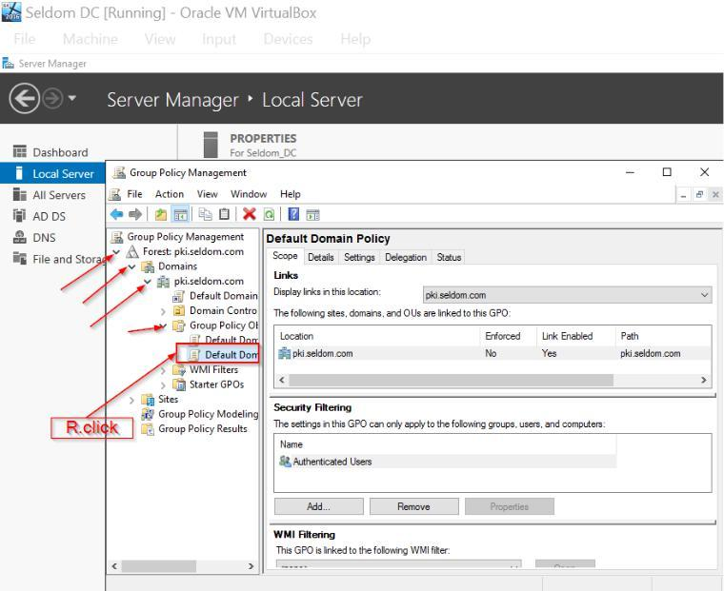

Figure 63 - Group-policy Management (B)

42

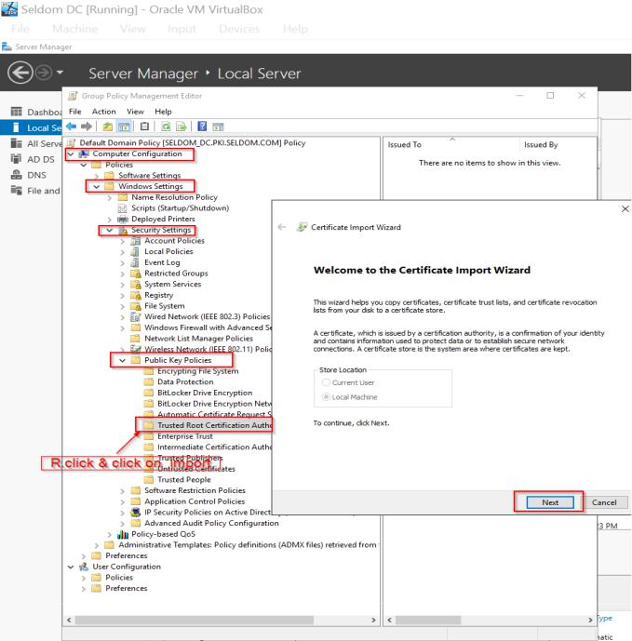

Figure 64 - Group-policy Management (C)

**Step 2**: Here, go back to the Root-CA server and copy the certificates, then paste it in a folder created in the issuer server(DC = pki.seldom.com) called “Certs” and share the folder.

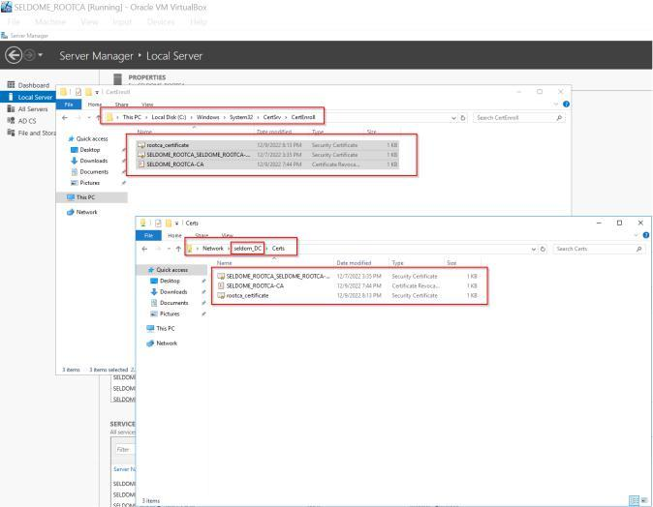

Figure 65 - Group policy Management importing CA Certificate (B)

43

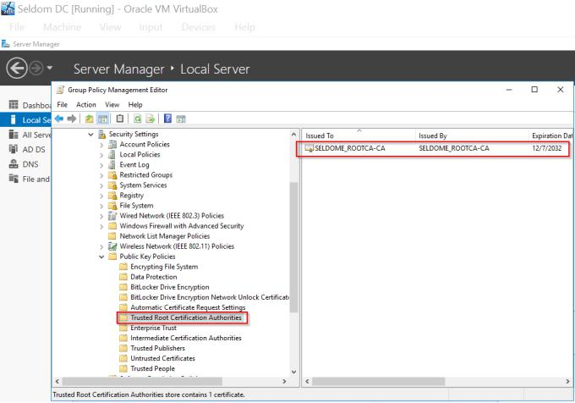

Figure 66 - Group policy Management importing CA Certificate (B)

**Step 3**: Run “GPUPDATE /FORCE in CMD to update the policy into the issuing Server(DC)

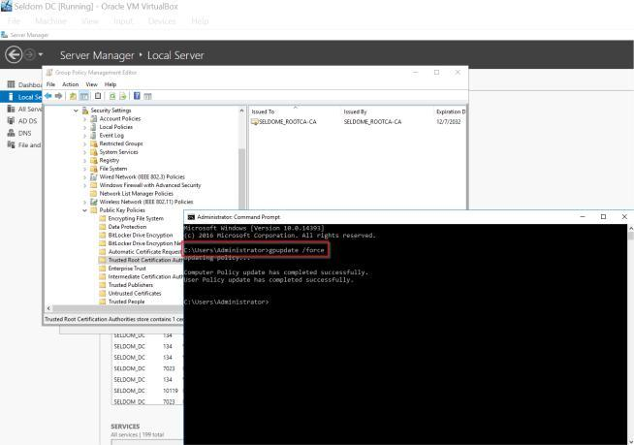

Figure 67 – Running gpudate

**Step 4**: So, to verify that the certificate is now available, go to Run and type certmgr.msc; you should see the certificate there already.

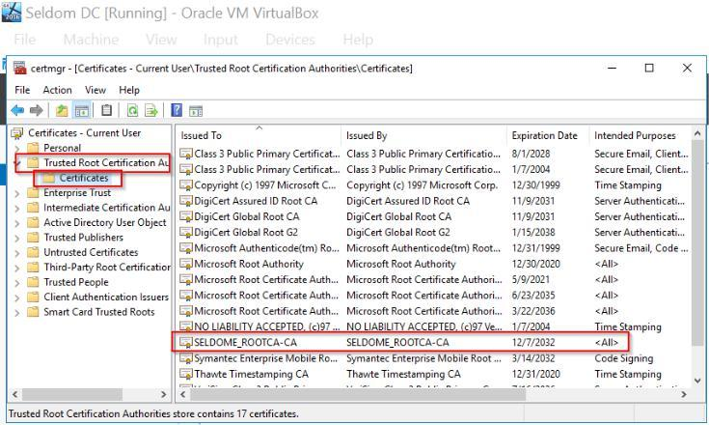

Figure 68 – Verifying Certificate

44

**3.9** **SERVER 3: SUBORDINATE CA**

**Step 1:** configuration of the name, network, and security.

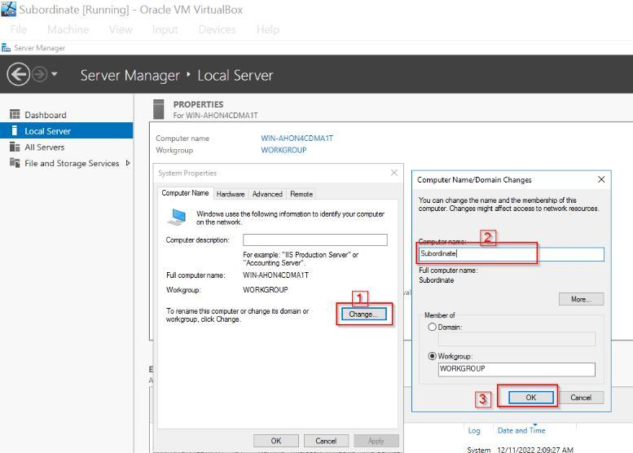

Figure 69: Subordinate Network’s settings

**Step 2:** Join the subordinate server to the domain. For the username and password, provide the admin username and password.

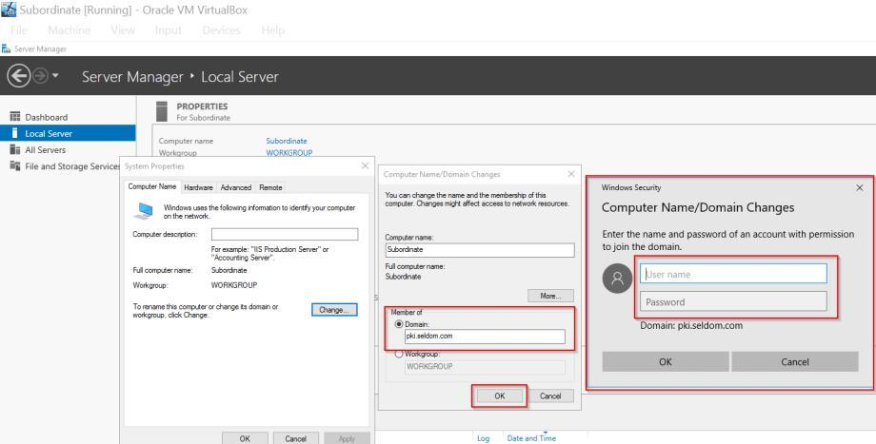

Figure 70: Subordinate Name and domain

45

**Step 3:** Verifying the changes made above

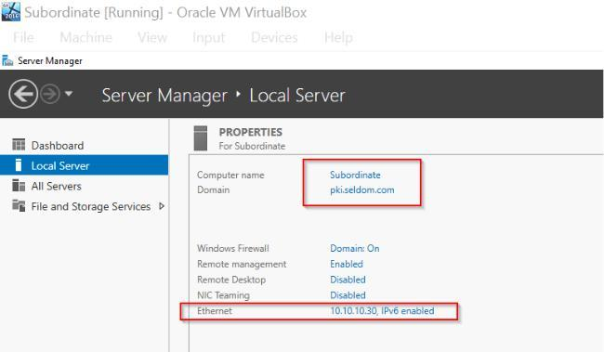

Figure 71 - Subordinate Configurations

**Step 4:** Addition of Roles and Features

As with the DC and RootCA servers, click on the "add role and feature" under "manage," then start clicking "next," and adhere to the instructions.

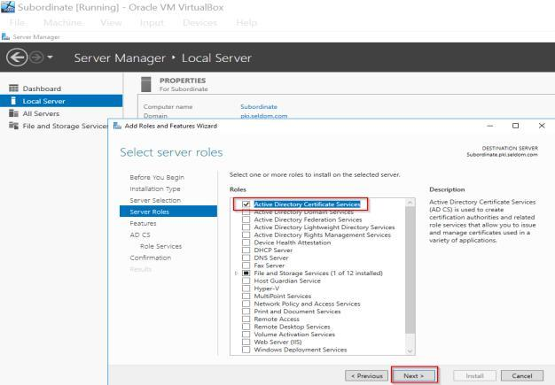

Figure 72 - Subordinate Roles (A)

**Step 5:** Install Active Directory Certificate service” and “Web server(IIS)”

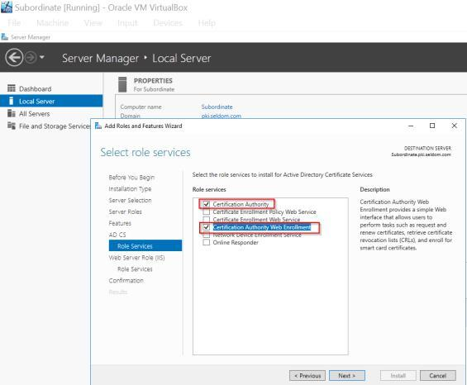

Figure 73 - Subordinate Roles (B)

46

Continue to click “Next” and click on "install," then click on the highlighted below and proceed to configure the ADCS.

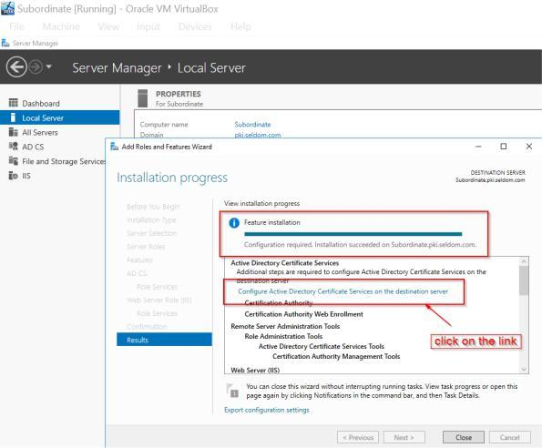

Figure 74 - Subordinate Roles (C)

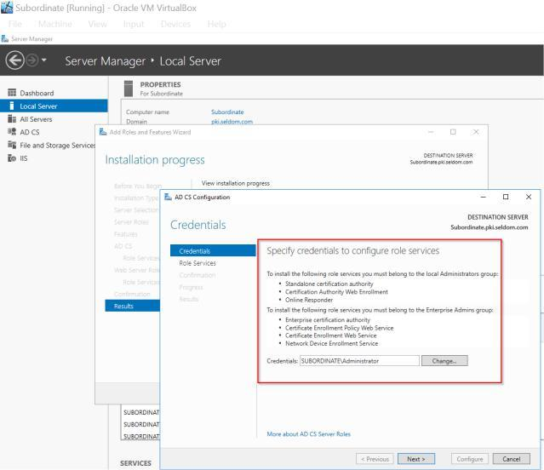

Figure 75: Subordinate Roles (D)

47

**Step 6:** Choose a Certification Authority and a Web Enrolment method. From the drop-down menu, select Enterprise CA.

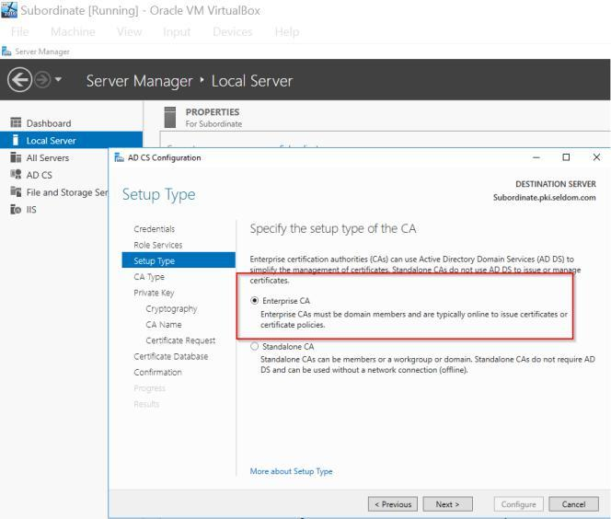

Figure 76: Selecting Server Role and Enterprise CA

**Step 7:** Choose Subordinate CA > Create a private key

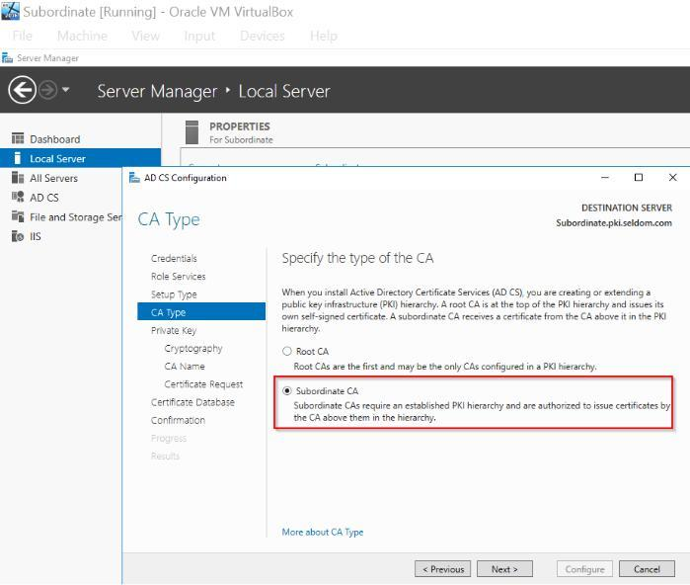

Figure 77: Subordinate CA

48

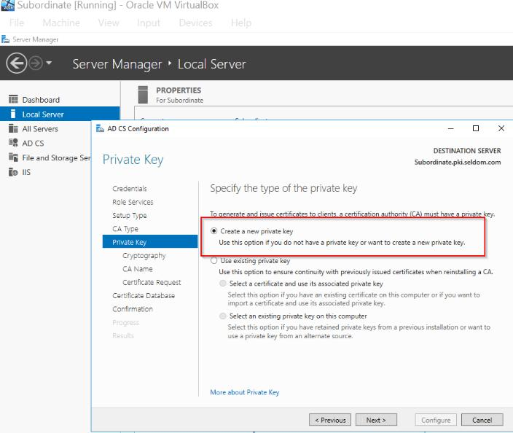

Figure 78: creating a private key

**Step 8:** As with the DC and RootCA server, click on the add role and feature under manage, then start clicking next and adhere to the instructions.

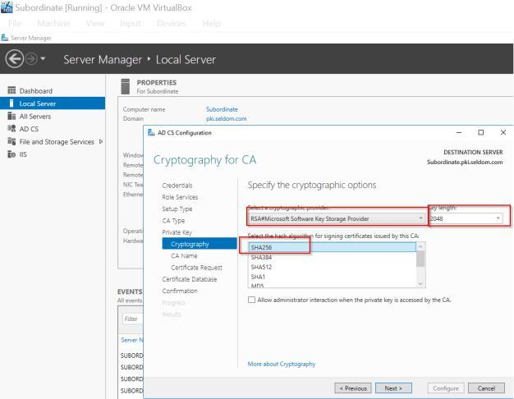

Figure 79: Subordinate cert-key length and CA name

49

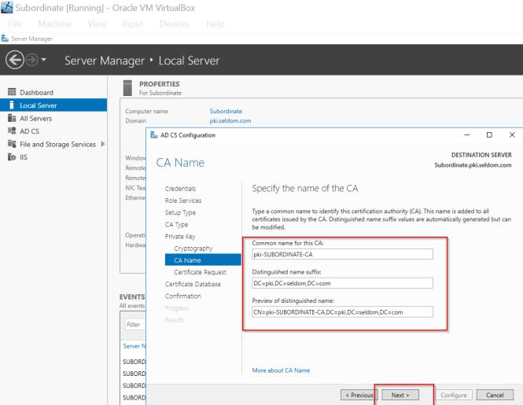

Figure 80: CA name

**Step 9:** Now, the default drive path for the subordinate certificate request will be to C:\ and the default database locations will be chosen.

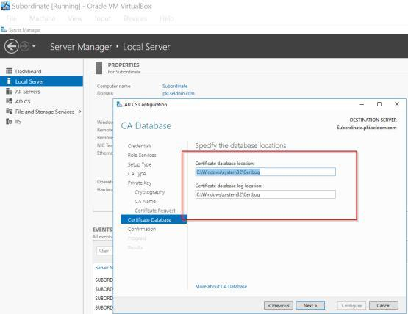

Figure 81: Subordinate Certificate and DB

50

**Step 10:** Verify the configurations

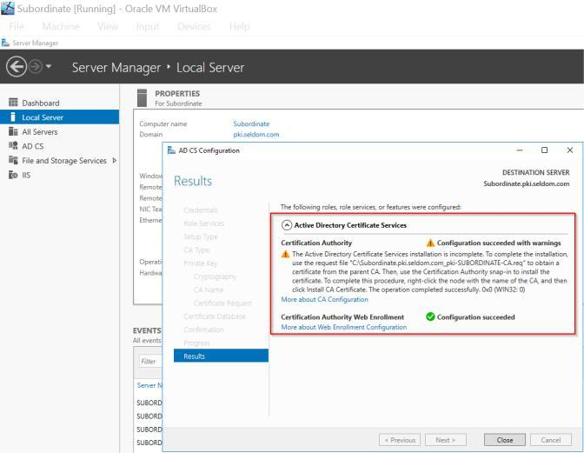

Figure 82 - Configuration confirmation

By now, the certificate will be located in the C: drive, and this will help us request the certificate from the ROOT_CA that will be given to the issuing CA (DC).

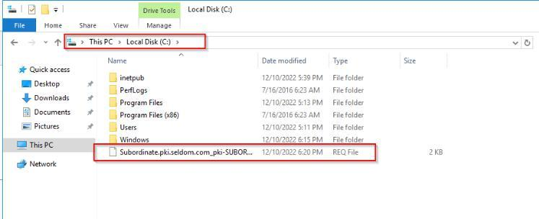

Figure 83 - Saved certificate

51

**3.10 INSTALLATION OF CA CERTIFICATE GENERATED FROM THE SUBORDINATE ROOT**

Now, access the ROOT_CA to place the request from the subordinate. Go to file-explorer and type "seldom_rootca" and press enter to have access to the ROOT_CA, where all the certificates are stored.

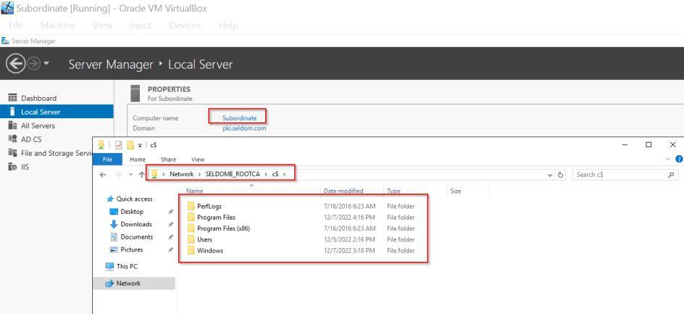

Figure 84 - Exporting Root Certificate (A)

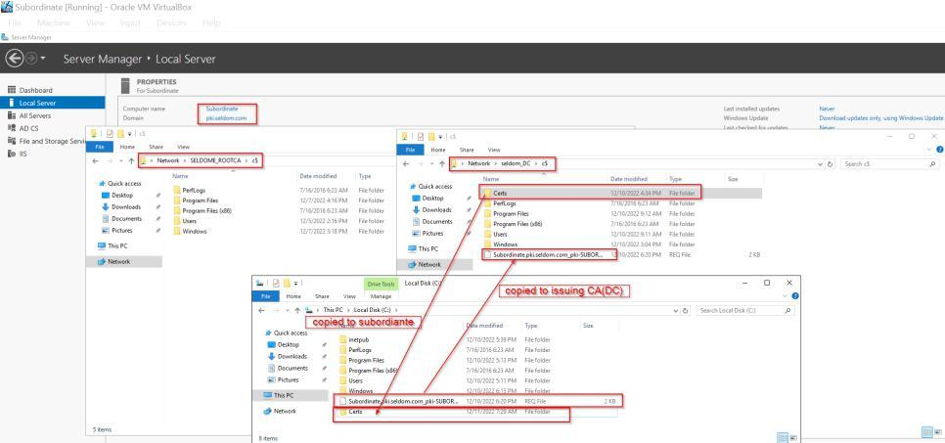

Figure 85 - Exporting Root Certificate (B)

52

**Step 2**: Now, go to ROOT_CA and click on Certificate Authority to open it.

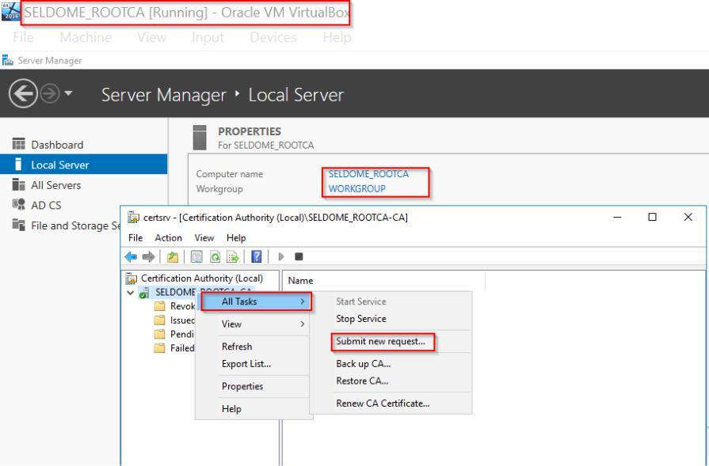

Figure 86 - Exporting Root Certificate (C)

**Step 3:** After clicking on “submit a new request,” navigate to the desktop where the request certificate is and select it. Then click on “pending request."

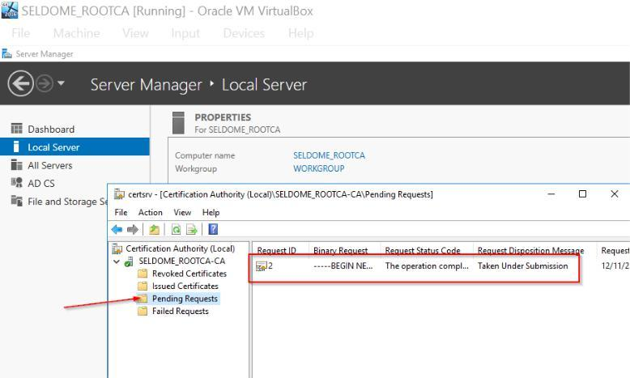

Figure 87 – Selecting Pending Request (A)

53

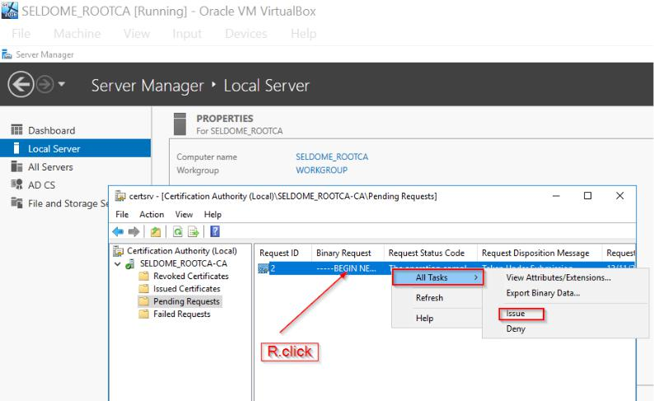

Figure 88 – Selecting Pending Request (B)

**Step 4:** Click on “issue” and then click on the issue certificate folder under seldom_rootca to locate the issued certificate.

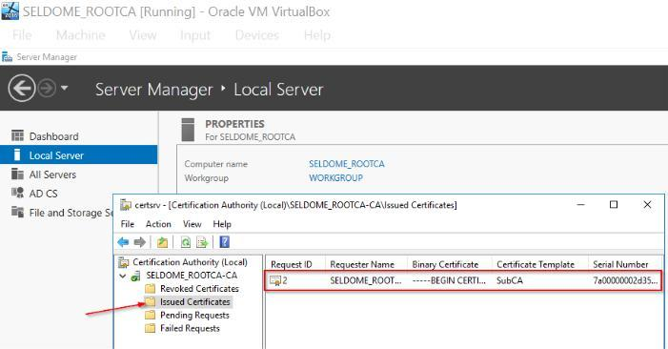

Figure 89 – Locating the issued certificate

**Step 5:** Now open the certificate to confirm the certificate has been issued to issuing_CA(DC)

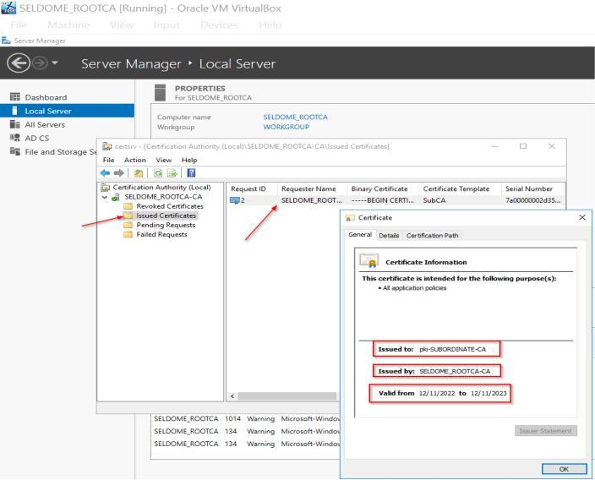

Figure 90 – Confirming Cert has been issued.

54

**Step 6:** Now click on “detail” on the certificate and copy the file and export it as a x.509 or .p7B file

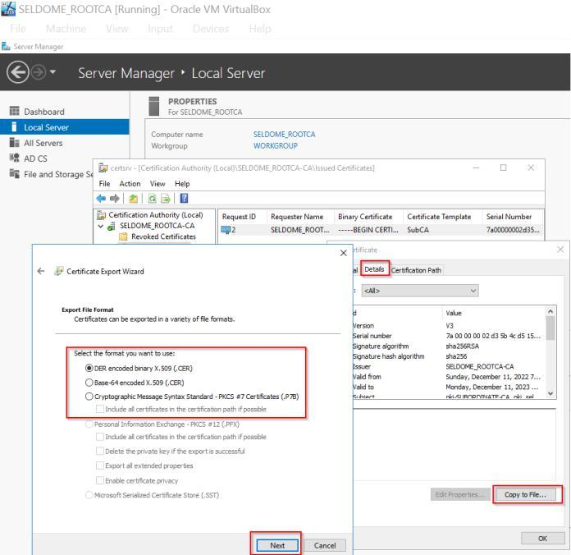

Figure 91: Exporting Certificate

**Step 7**: Click Next to save the file in the default preset folder. Now, copy the saved certificate from the ROOT_CA (CertEnroll) folder into the shared folder (Certs), which was opened from subordinate.

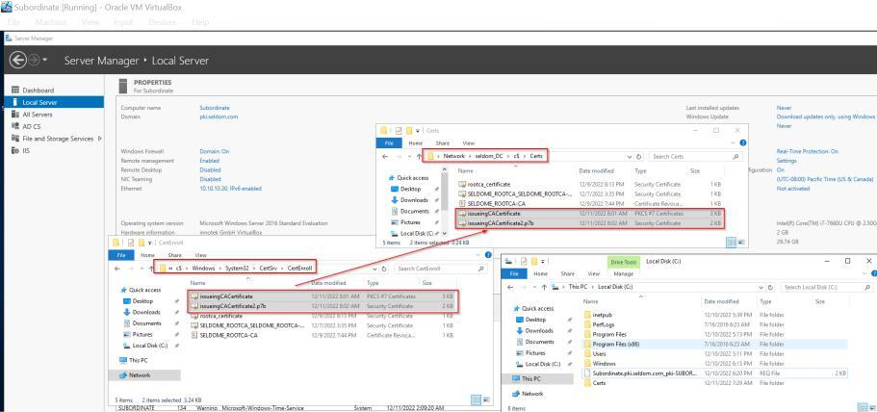

Figure 92: Copying saved certificate (A)

**Step 8**: Also copy the two files and save them in the wwwroot folder.

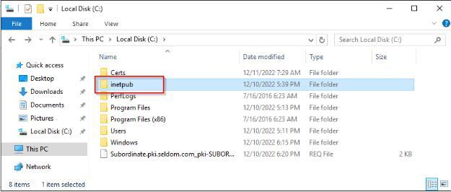

Figure 93: Copying saved certificate (B)

55

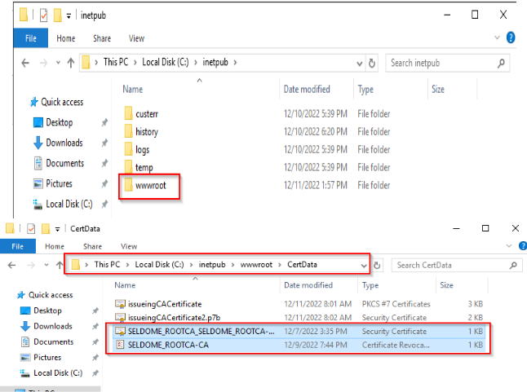

Figure 94: Copying saved certificate (C)

**Step 9**: Now goto “Tools” and click on Certificate Authority to install CA certificate.

Now, we might receive a warning message of the certificate that cannot be verified, this is possible because our CDP(web server) is not yet configured.

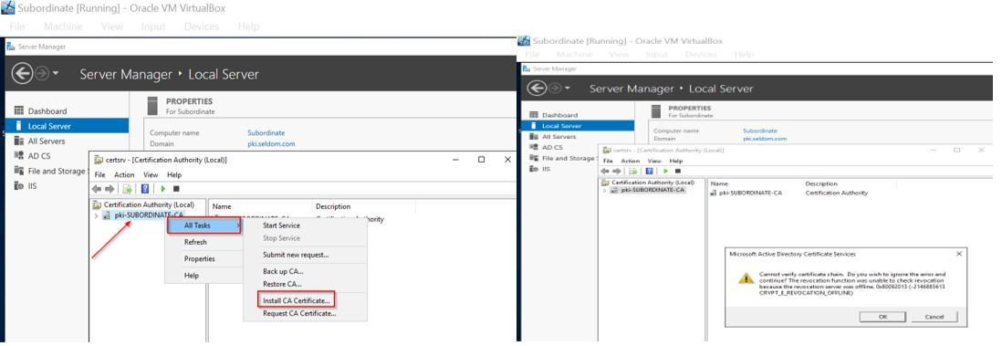

Figure 95: Installing CA Certificate

**Step 10**: Right click on the PKI-SUBORDINATE CA and choose “properties”

56

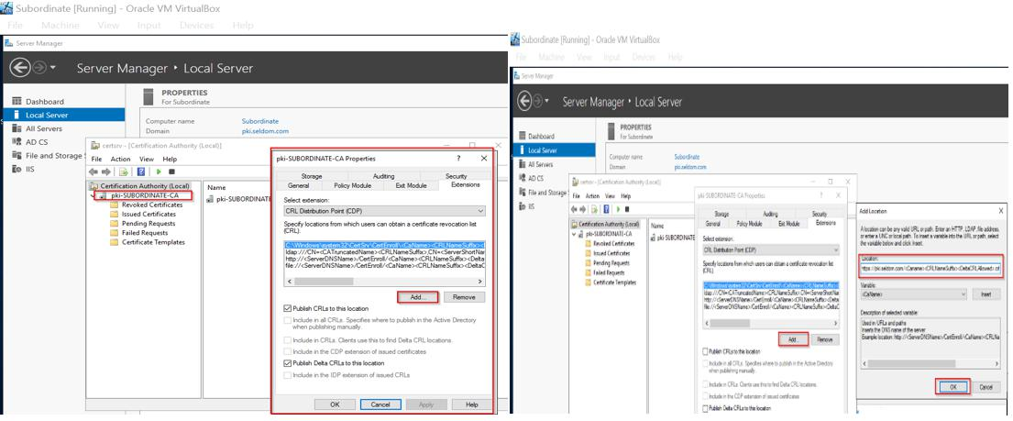

Figure 96: Selecting Properties

**Step 11:** After the setup, click on “Apply and ok” then the issuing CA web root folder (inetpub\wwwroot) should be populated with the Root CA.crt files.

**Step 12:** Apply the same setup to AIA as well.

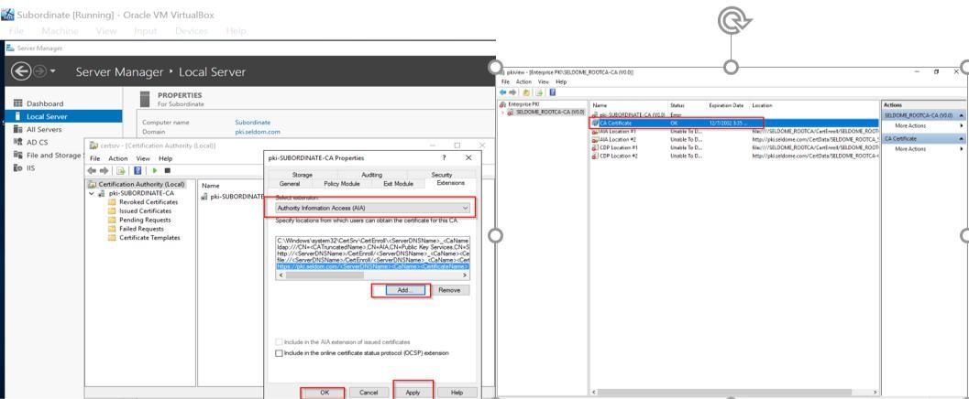

Figure 97: Applying setup to AIA

Now the issuing CA is ready for the network and we can decide to shut down the Root CA.

57

**4.0** **CREATE A FULLY OPERATIONAL TLS- ENABLED WEB PAGE**

Since we copied the root certificate and subordinate certificate to the wwwroot folder during the configuration, we can move on to the IIS Manager.

**Step 1:** Click on the “Internet Information Service (IIS) Manager” under Tools, the image below will be displayed

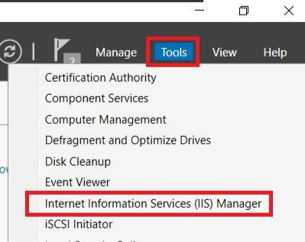

Figure 98: IIS Manager

**Step 2**: To set up a new domain certificate, enable the server certificate.

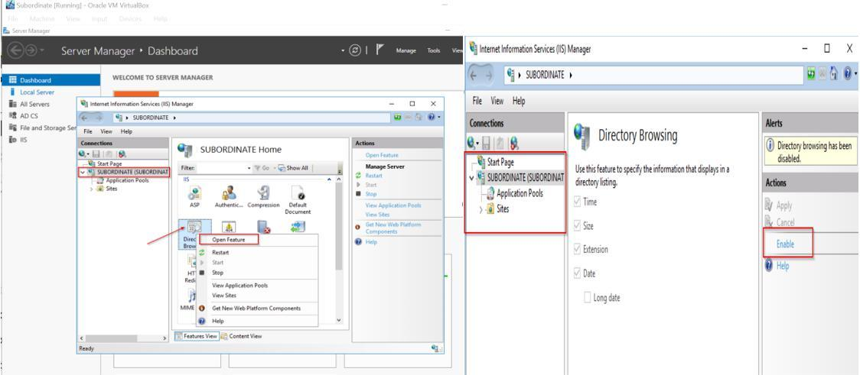

Figure 99: Create a new domain certificate (A)

58

**Step 3:** To create a new domain certificate, open the server certificate window and fill out the form's details.

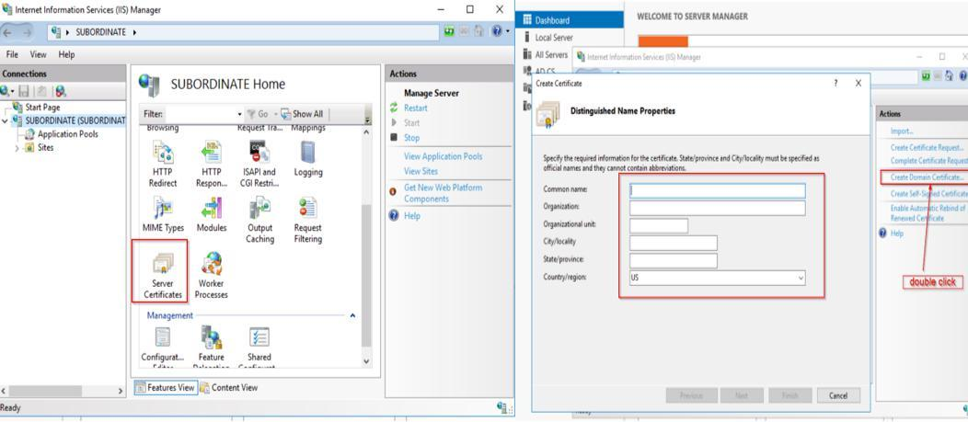

Figure 100: Create a new domain certificate (B)

**Step 4**: Choose the Cert Authority as the subordinate authority and provide a domain name.

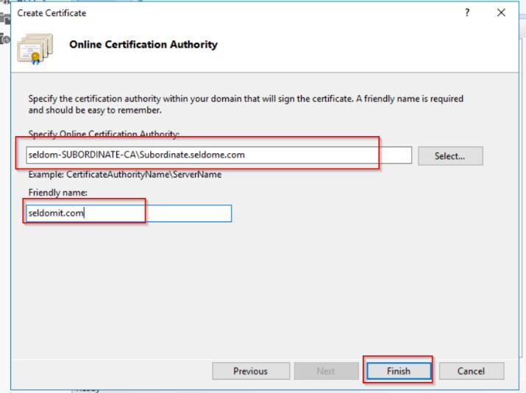

Figure 101: Providing a domain name on the Cert. Auth

**Step 5**: Confirmation of server certificates

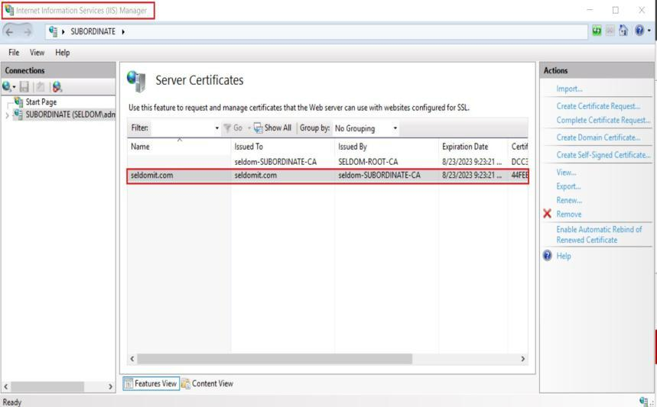

Figure 102: Confirmation of the generated server certificate

**Step 6:** Add the domain name, connect the directory with the administrator password, and set the domain's protocol to https.

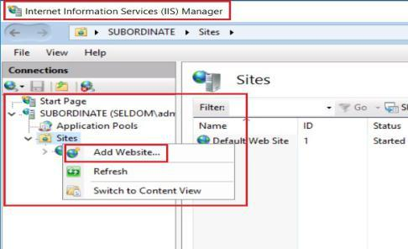

Figure 103: Connect Directory with Admin Credentials(A)

60

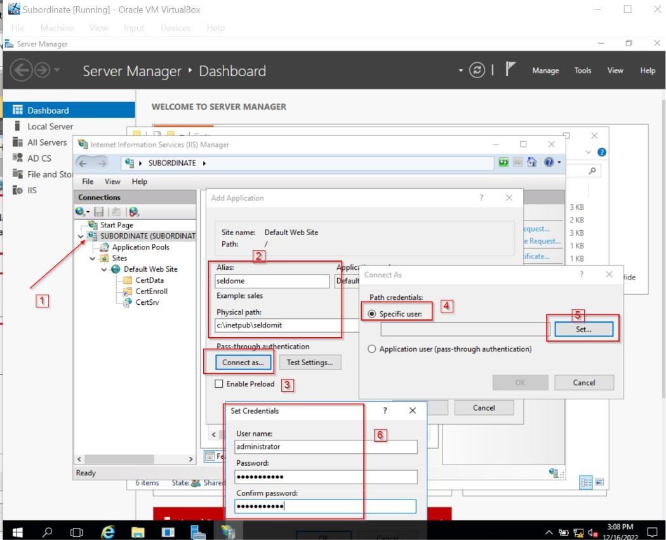

Figure 104: Connect Directory with Admin Credentials(B)



| **WEBSITE NAME** | Seldomit.com |
| --- | --- |
| **PATH** | C:\inetpub\seldomit |
| **PROTOCOL TYPE** | https |
| **IP ADDRESS** | 10.10.10.30 |
| **PORT** | 443 |
| **SSL CERTIFICATE** | Seldomit.com |

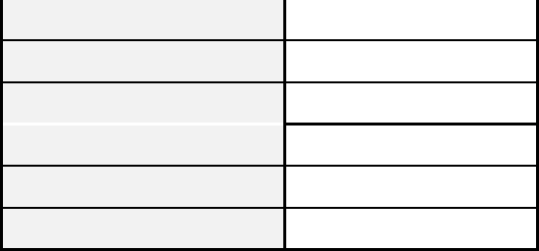

Table 1: Configuration of Website

61

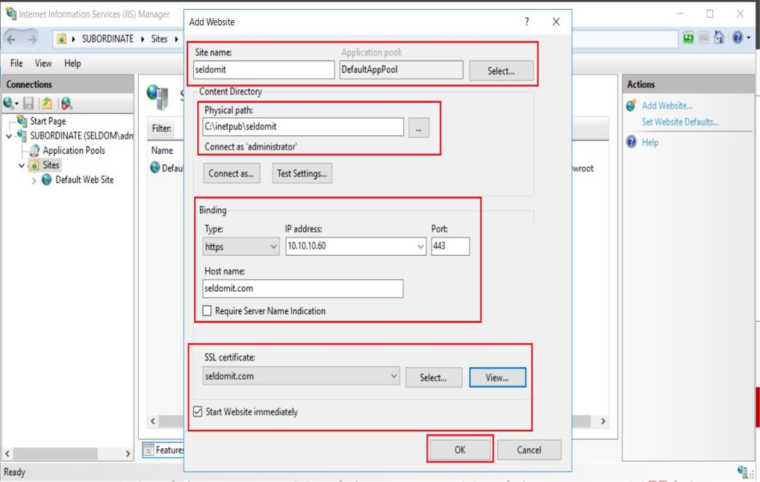

Figure 105: Website Config.

**Step 8:** To verify the website status on the browser, do the following:

* Open the internet explorer
* Enter the domain name https://seldomit.com
* Verify the certificate

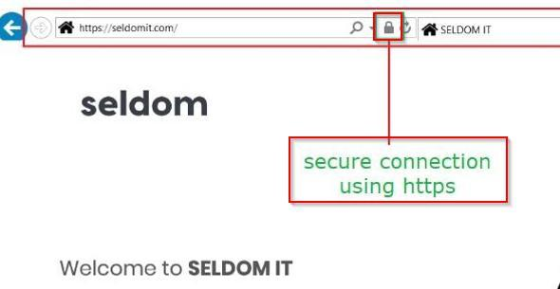

Figure 106: Seldomit Website

Now click the lock icon on the browser to open the certificate.

62

**Step 9:** We will utilize the Wireshark program to track the website's traffic. Secure TLS V1.2 and encryption are used to ensure all end-user communications with the website domain name (seldomit.com).

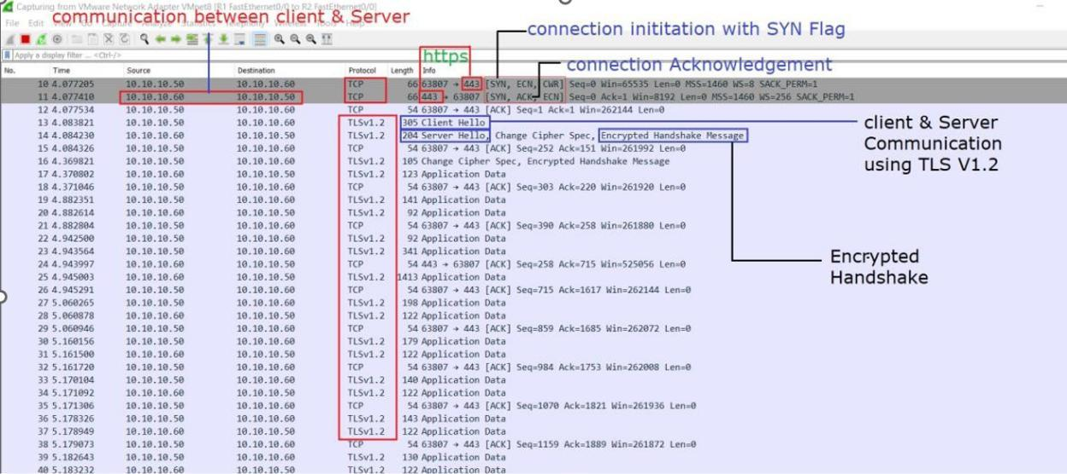

Figure 107: Wireshark Analysis

**5.0** **SSL THREAT MODELLING & ETHICAL IMPLICATIONS**

Threat modeling is a method of estimating the risks associated with cybersecurity threats. It entails locating possible holes or vulnerabilities in a system and putting defenses in place to prevent attacks. Threat modeling is a systematic approach that involves determining the security needs of a system, identifying security threats and vulnerabilities, calculating the criticality of these threats and vulnerabilities, and prioritizing corrective actions based on their impact and likelihood. Administrators can use threat modeling techniques to guide defensive activities and protect against potential attacks.

Various Internet programs rely on public key infrastructure(PKIs) and secure socket layer/transport layer/transport layer security protocols for security. PKIs rely on digital certificates and certificate authorities (CAs) to authenticate devices or persons and build trust between parties. The Web PKI, which is a collection of PKIs used for SSL certificate issuance and administration, has become large and complex over time. Each CA acts as a single point of failure in this scenario, meaning that the attack surface is uncertain and there is a potential for attacks to compromise the security of the system. Protocols such as HTTP and IMAP use PKI and SSL/TLS infrastructures to secure communication.

63

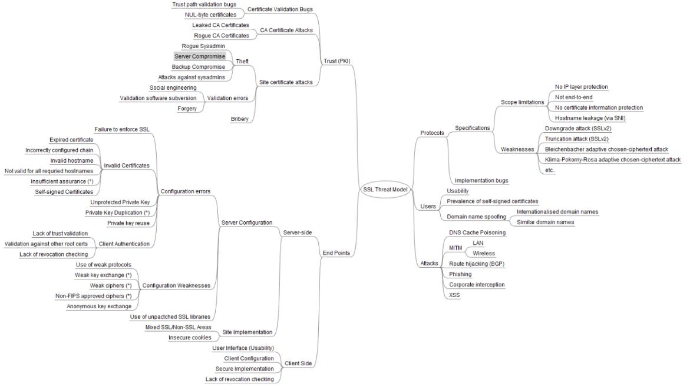

Figure 108 - PKI-SSL Threat Model (Qualys, n.d.)

The Public Key Infrastructure (PKI) system is a critical component of Internet security, providing the foundation for a network of Certificate Authorities (CAs) that verify the identity of devices or individuals and establish trust between parties. However, the PKI system has several weaknesses that can compromise its effectiveness.

One major weakness of the PKI system is the increasing number of efforts to obtain false certifications. Commercial CAs are responsible for verifying the authenticity of entities and authorizing them to run particular websites, but this process can be challenging due to the global nature of the Internet and the need to function consistently across different countries, legal systems, and cultural norms. In addition, the volume of SSL certificate requests that CAs must handle on a daily basis often requires part of their activities to be outsourced, which can introduce additional vulnerabilities.

Another weakness of the PKI system is the use of inadequate revocation mechanisms. Currently, PKI relies on Certificate Revocation Lists (CRLs) to identify untrusted certificates and prevent their use. However, CRLs are frequently published and may not include newly created fake certificates until they are updated, which can leave a window of vulnerability.

A third major weakness of the PKI system is a lack of transparency. The many trust linkages that must be established for the system to function effectively are often not clearly visible to users, leading to confusion and uncertainty about the trustworthiness of SSL-encrypted websites. This can be further exacerbated by inconsistent browser interfaces and the changing significance of trust indicators like the padlock emblem.

64

Microsoft's threat modeling approach, known as STRIDE, is a method of classifying different threats in order to identify and prioritize potential risks. STRIDE stands for spoofing Tampering, Repudiation, Information disclosure, Denial of service, and Elevation of privilege.

Spoofing refers to the use of counterfeit server certificates, also known as homophones or similarly similar certificates, to tie the attacker's public key to the domain name of the target website. This can allow the attacker to impersonate the target website or conduct a man-in-the-middle attack if the user's browser trusts the counterfeit certificate.

Tampering attempts to bypass trust protocols, such as SSL certificates, attempting to bypass protocols, such as SSL certificates, in order to convince users or protocols, such as SSL certificates, systems to trust the attacker's own resources, such as falsely signed websites or programmes. This can jeopardize the system's security and perhaps provide the attacker access to critical information.

Repudiation happens when a system or program fails to provide controls that consistently track and report the user's behaviors, allowing the possibility for malicious manipulation or the creation of new actions. This allows the attacker to wrongly modify the authorship information of harmful activities and log data, resulting in untrustworthy or misleading data in the log files. This might erode the system's credibility and potentially lead to breaches.

Disclosing confidential data to a user who is not authorized to access it is known as information disclosure. This can result from as a result of a CA certificate assault, a site certificate attack, weaknesses in the CA certificate validation process, or a CA certificate forgery. Individuals' privacy may be jeopardized, and confidential material may be stolen as a result.

Denial of service occurs when an attacker consumes all the resources necessary to serve users through illegitimate means, effectively rendering the system unable to function. Several cyberattacks, including man-in-the-middle attacks, DNS cache poisoning, ARP spoofing, cross-site scripting, cooperative interception, route hijacking, and BGP (Border Gateway Protocol) attacks, among others, can result in a denial-of-service attack in a PKI SSL (Public Key Infrastructure Secure Sockets Layer) environment.

Giving someone without the appropriate authorization access to commands and functions is referred to as "elevating privilege." This can happen through attacks like SSL downgrade attacks, truncation attacks, and other attacks that could raise the attacker's degree of privilege as a result of errors in the way a protocol is implemented. As a result, the attacker could be able to access private data without authorization and endanger the system's security.

.

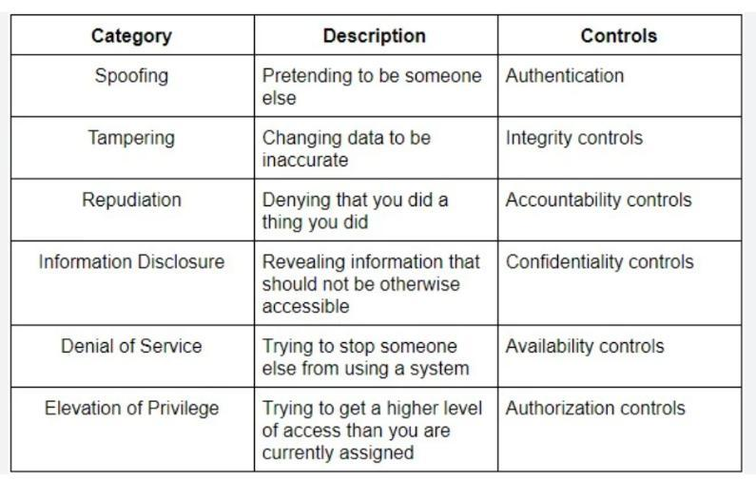

Figure 109: Threat Modelling with STRIDE

65

**5.1**  **RANKING THE PKI SSL THREATs**

The degree to which each direct threat affects the PKI SSL model is specifically considered throughout the threat ranking procedure. The PKI SSL Model's risk score is listed below.

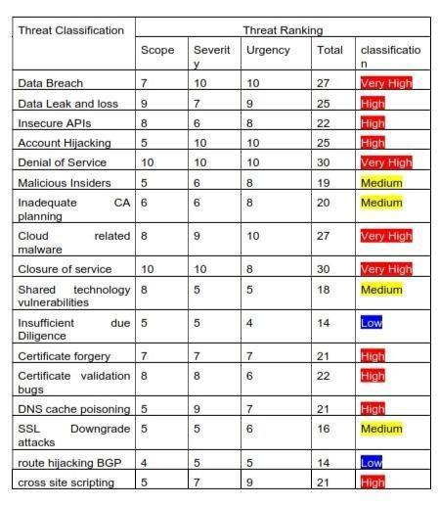

Figure 110: Threat Ranking

If the method or the public key certificate were to be hacked, a number of security incidents may happen in the PKI. There are several possible threats to the PKI, some of which we shall look at below. Because they might be used to trick users into believing a network is safe, software flaws in the certification process for public keys pose a security risk.

The Root Certification Authority's (CA) Root Certification Program Requirements may not be strictly adhered to by all certificate authorities. If the issue is due to improper processes or something connected to them, it is a procedural mistake.

Any mistake done by a person, such as a typing error during data input or a neglected step in a related process, is referred to as a "human error."

**5.2** **PKI SSL THREAT MITIGATION**

In environments currently using SSL or early TLS protocols, implementing risk-mitigation strategies can help protect against potential vulnerabilities. Some potential strategies include:

* Restricting the IP addresses or parties who can utilize the vulnerable protocols. To achieve this, firewalls may be configured to only permit SSL/early TLS transmission for known IP addresses and to prohibit it for all other ones.
* The entire network can be decreased by reducing the number of systems that support the protocols and concentrating the functions that rely on them on fewer devices.
* Disabling or removing unnecessary web browsers, session cookies, and JavaScript can also help reduce the risk of attack.

66

* Implementing measures to restrict communications using the vulnerable protocols, such as identifying and rejecting attempts to downgrade to an earlier protocol version, can help protect against attacks.
* Improving detection and prevention capabilities can involve expanding the coverage area of intrusion protection systems, updating signatures, and stopping network activities that may indicate hostile activity.
* Attacks can be detected and prevented by maintaining an eye out for suspicious activity, such as unusual surges in requests for fallback to susceptible protocols, and acting appropriately.
* Vulnerabilities can be avoided by switching to a more recent, secure version of TLS that is set up to forbid fallback to SSL or an earlier version of TLS.
* Using strong cryptographic techniques, such as field-level or application-level encryption, to encrypt data before transmitting it via SSL or early TLS can help protect against data breaches.
* Establishing a secure tunnel, such as an IPsec tunnel, and establishing a strongly encrypted connection before sending data over SSL can help protect against man-in-the-middle attacks.
* Implementing Certificate Authority Authorization (CAA) records allows domain name owners to specify the CAs that are authorized to issue certificates for their domains, and CAs agree to respect the CAA records of the domain name owners. This can help prevent the issuance of fraudulent certificates for a domain.
* Implementing Certificate Transparency (CT) allows for the tracking of TLS certificates and can help identify which CAs have issued certificates for a domain. This can help detect and prevent the issuance of fraudulent certificates.
* Regularly patching and updating systems and software can help prevent known vulnerabilities from being exploited.
* Implementing strong password policies and using two-factor authentication can help protect against unauthorized access.
* Providing security awareness training to employees can help them recognize and avoid potential threats.

**5.2.1** **MITIGATION ACCOMPLISHED PRIMARILY THROUGH MAPPING**

In order to mitigate the risks associated with compromised SSL certificates, it is important to implement a strategy that involves severing the connection between the compromised certificates and the principals in cases where services perform principal mapping based on the client's certificate after an SSL connection has been established. This can be achieved by deactivating or deleting the principal and creating a new one if the mapping between the principal and the username is fixed. By doing so, it will prevent the compromised but still valid certificate from being able to map to a recognized security principal, resulting in the failure of authentication. This helps to prevent attackers from using compromised certificates to gain unauthorized access to a system. It is crucial to implement these measures in a timely manner to ensure the security of the system and protect against potential threats.

67

**5.2.2** **THE USE OF CLIENT CERTIFICATES AS A MITIGATING FACTOR**

The use of client certificates as a mitigating factor in the event of compromised SSL certificates is an important consideration when implementing security measures. It is essential to carefully evaluate the platforms and services currently in use in order to choose appropriate mitigations that will effectively protect against potential threats. One effective method of mitigating the risks associated with compromised SSL certificates is the implementation of host-level mitigations on all nodes that may communicate with clients that submit such certificates. This is especially important as there is no centralized system in place for verifying the status of client certificates, such as a Certificate Revocation List (CRL) or Online Certificate Status Protocol (OCSP). By implementing these measures, it is possible to reduce the risks associated with compromised SSL certificates and ensure the overall security of the system.

**5.3** **PKI RISKS**

Public Key Infrastructure (PKI) is a cybersecurity system that utilizes encryption and authentication to protect client-server connections. It is commonly used to ensure the confidentiality, integrity, and authenticity of electronic transactions and communications. However, even with PKI in place, there are still risks to the security of digital identities.

According to a survey conducted by the Ponemon Institute, 73% of IT and security experts have experienced issues or outages related to digital certificates. Additionally, only 74% of respondents said that their company had a clear understanding of how many keys and certificates it was using and when they would expire. This lack of understanding can damage trust in the organization. The increasing use of encryption can also lead to increased operational complexity and cost. 66% of respondents reported that they were using additional layers of encryption to meet legal and IT policy requirements, and 58% said that it was becoming more expensive to manage a larger number of keys and certificates.

In terms of PKI management, 38% of respondents said that their IT staff was sufficient to support PKI, while 19% and 21% reported that business units and IT operations, respectively, shared the cost. 13 percent of respondents stated that there was no designated individual in charge of PKI management. On average, PKI cost respondents $3 million, or 16% of their security expenditure (Josh Fruhlinger 2020).

**6.0** **CONCLUSION**

This evaluation assesses the PKI-certified website for the SELDOM Organization and finds that it has a clear and well-structured authentication process. The primary aim of using a public key infrastructure (PKI) is to formally represent the authentication method used by SSL (Secure Sockets Layer) and PKI. As part of this project, we have described the risks associated with using PKI and identified the ranking of the dangers and risks associated with its use. Additionally, we have described the process for risk management and key creation using PKI.

68

**REFERENCES**

Shevchenko, N. (2018) Threat Modeling: 12 Available Methods [online] SEI Blog. Available at: <https://insights.sei.cmu.edu/blog/threat-modeling-12-available-methods/>.

Hohlfeld, O., Lutu, A., and Levin, D. eds., 2021). Passive and Active Measurement Lecture Notes in Computer Science, Cham: Springer International Publishing, doi:[10.1007/978-3-030-72582-2.](https://link.springer.com/book/10.1007/978-3-030-72582-2)

Braun, J., and Rynkowski, G. (2013). The Potential of an Individualized Set of Trusted CAs: Defending against CA Failures in the Web PKI. 2013 International Conference on Social Computing. doi:[10.1109/socialcom.2013.90](https://ieeexplore.ieee.org/abstract/document/6693387/)

Gonzalez, C. (2020). 6 Threat Modeling Methodologies: Prioritize and Mitigate Threats [online] Exabeam. Available at: <https://www.exabeam.com/information-security/threat-modeling/.>

Securityweek.com. (2019). Examining Public Key Infrastructure (PKI) and Secure Socket Layer (SSL) Threats SecurityWeek.com [online] Available at: <https://www.securityweek.com/examining-threats-facing-public-key-infrastructure-pki-and-secure-socket-layer-ssl.>

Fruhlinger, J. (2020) What is PKI, and how does it work? [online] Available at: <https://blog.passwork.pro/pki/> [Accessed December 12, 2022].

Holz, R., Braun, L., Kammenhuber, N., and Carle, G. (2011). The SSL landscape The proceedings of the 2011 ACM SIGCOMM conference on Internet measurement conferences (IMC '11; doi:[10.1145/2068816.2068856](https://dl.acm.org/doi/10.1145/2068816.2068856))

A. Reffett and T. Scanlon, "Implications and Mitigation Strategies for the Loss of End-Entity Private Keys," Carnegie Mellon University's Software Engineering Institute Blog, March 19, 2018. [Online]. Available at: <https://insights.sei.cmu.edu/blog/implications-and-mitigation-strategies-for-the-loss-of-end-entity-private-keys>/ [Accessed: January 6, 2022].

69